THE EAGLES - HOTEL CALIFORNIA (versi Akustik)
TAB SEMUA GUITAR CLASSIC SOLO
Intro Bag-1

Tab Guitar 1 : Solo ke-1

Bm7 B7(4/9)
e|------------------------------------- -------------------------
B|-------------------5-7-7/8\7-5/7--------3-2--------------------
G|---4-4h6p7\3-4-6-7------------------2-4-------2-2h4-2----------
D|--------------------------------------------4---------4\2-0/2--

Em
e|--------0-------0-------0-------0-----7p0-----10p0-----7p0-----
B|------0-------0-------0-------0-----8-------8--------8---------
G|----0-------2-------4-------7-----9-------9--------9-----------
D|--2-------4-------5-------9------------------------------------

e|------7p0-----10p0-----7p0-----10p0-----7p0-----10p0-----7p0---
B|----8-------8--------8-------8--------8-------8--------8-------
G|--9-------9--------9-------9--------9-------9--------9---------
D|---------------------------------------------------------------

F#7
e|--------10p0-----7p0-----10p0-----7-6-7-9-10-9-10-12/14—-14 ~~~
B|------8--------8-------8--------8------------------------------
G|----9--------9-------9--------9--------------------------------
D|---------------------------------------------------------------

Tab Guitar 2 (strum utk startup solo)
Bm7 B7(4/9) Em F#7
e|--2-----------------2--------------------0-----------------2-----
B|--3-----------------2--------------------0-----------------2-----
G|--4-----------------2--------------------0-----------------3-----
D|--4-----------------2--------------------2-----------------2-----
A|--2-----------------2--------------------2-----------------4-----
E|-----------------------------------------0-----------------2-----

Tab Guitar 3 (strum utk startup solo)
Em7(9) D9/E Am B7
B |--2---------------0-----------------0------------------------2--
F#|--0---------------3-----------------1----------------------0-0--
D |--0---------------2-----------------2--------------------2---2--
A |--2---------------4-----------------2------------------1-----1--
E |--2---------------5-----------------0----------------2-------2--
B |--0---------------0---------------------------------------------
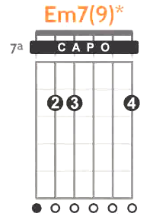
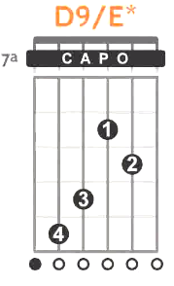
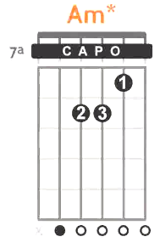
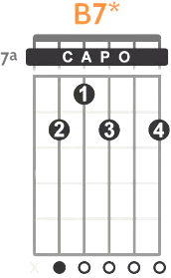

Intro Bag-1 Status Gitar Semua Diam ...

HANYA PERCUSSI (Conga) ........ panjang 8-beats

Intro Bag-2
Tab Guitar 1 : Solo ke-2

Bm7 B7(4/9)
e|----2h3p2---2-2---2--------------------------------------------
B|----------5-----5---3—5p3---0---------3p2---2-2----------------
G|--4-----------------------4---2/4-2-4-----4-----2-4-6-7--------
D|---------------------------------------------------------------

Em
e|------------7-9-10-9-10-12\0-------0------0------0------0-7p0--
B|-5-8-7-8h10----------------------0------0------0------0--------
G|-------------------------------0------2------4------7----------
D|-----------------------------2------4------5------9------------

F#7 Bm
e|---10-12-10----9-9h10p9\7-7h9p7\6------------------------------
B|-0----------12----------------------8-7-7-7-8-7---7------------
G|------------------------------------------------9---7-6--------
D|--------------------------------------------------------9-8----

Tab Guitar 2 Intro Bag-2 mengiringi solo-2

Bm7 B7(4/9) Em F#7
e|--2-----------------2--------------------0-------------------2--
B|--3-----------------2--------------------0-------------------2--
G|--4-----------------2--------------------0-------------------3--
D|--4-----------------2--------------------2-----------------2----
A|--2-----------------2--------------------2--------------4-------
E|-----------------------------------------0-----------2----------

Tab Guitar 3 Intro Bag-2 mengiringi solo-2

Em7(9) D9/E Am B7
B |--2-----------------0--------------------0-------------------2--
F#|--0-----------------3--------------------1-----------------0-0--
D |--0-----------------2--------------------2---------------2---2--
A |--2-----------------4--------------------2-------------1-----1--
E |--2-----------------5--------------------0-----------2-------2--
B |--0-----------------0-------------------------------------------

Intro Bag-3

(Guitar 1,2 dan 3 main bersamaan, chord dipetik)

Tab Guitar 1 Intro Bag-3
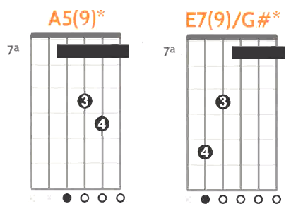
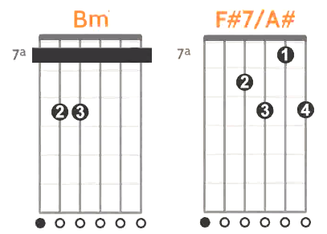
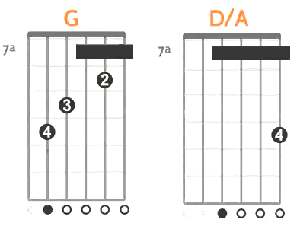
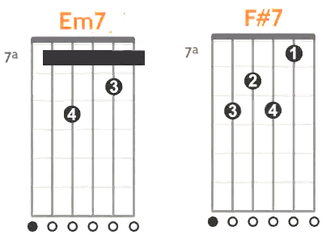
Bm F#7/A#
E|-----------7--------------9--------
B|-------7----------------7-----7----
G|-----7---7---7-9------9-----9------
D|---9----------------8--------------
A|-----------------------------------
E|-7---------------------------------

A5(9) E7(9)/G#
E|---------7---------------------7---
B|------10-----10------------7-------
G|----9------9----9--------7---7-----
D|--7--------------------9-----------
A|--------------------11-------------
E|-----------------------------------

G D/A
E|-----------7--------------10-------
B|-------8-----------------7---------
G|-----7---7-------7-----7-----7-----
D|---9---------7h9-----7-------------
A|-10----------------------------9---
E|--------------------------------10-

Em7 F#7
E|------------7-------------0--------
B|--------8-------------7------------
G|------7---7---------9---9----------
D|----9-------------8----------------
A|--7-------------9------------------
E|-----------------------------------

Tab Guitar 2 Intro Bag-3

Bm F#7 A E7
E|------------2-----------------2--|------------5---------------0-
B|--------3-----3-----------2------|--------2-----2---------0-----
G|------4---4-------------3---3----|------2---2-----------1---1---
D|----4-----------------2----------|----2---------------0---------
A|--2------------------------------|--0---------------------------
E|-------------------2-------------|------------------0-----------

G D Em F#7
E|------------------------2---2----|------------0---------------2-
B|------------3---------3-------3--|--------0---------------2-----
G|--------4-----4-----2-----2------|------0---0---0-------3---3---
D|------5---5-------0--------------|----2---------------2---------
A|----5----------------------------|------------------------------
E|--3------------------------------|--0---------------2-----------
Tab Guitar 3 Intro Bag-3
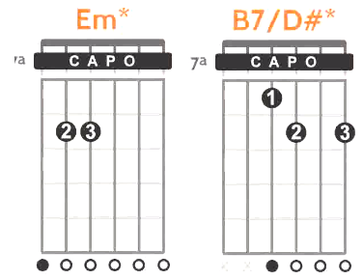
Em B7/D#
B |---------------------------2----2---
F#|------------0------------0------0---
D |--------0-----0-2------2-----2--2---
A |------2---2----------1----------1---
E |----2-------------------------------
B |--0---------------------------------
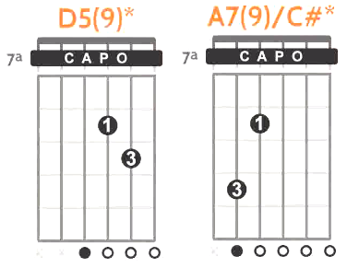

D5(9) A7(9)/C#
B |--------0--------------------0------
F#|------3-----3------------0---0------
D |----2-----2---2--------0---0-0------
A |--0------------------2-------2------
E |-------------------4---------4------
B |------------------------------------
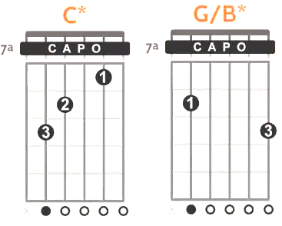

C G/B
B |------------0--------------3----3---
F#|--------1----------------0------0---
D |------0-----------0----0-----0--0---
A |----2-----2---0h2---------------0---
E |--3------------------2----------2---
B |----------------------------------3-
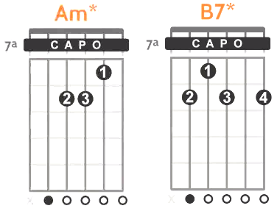

Am B7
B |------------0---------------2-------
F#|--------1--------------0------------
D |------2---2----------2---2----------
A |----2--------------1----------------
E |--0--------------2------------------
B |------------------------------------

Intro Bag-4
(Guitar 1 Solo ke-3, di iringi Petikan Guitar 2 dan 3)

Tab Guitar 1 Intro Bag-4 : Solo ke-3

Bm F#7 A E7
e|-------------------------------------------------------------0--
B|----------------------------------------------------------------
G|----------------------------------------------------1-----1----
D|-------------------------------------------------0-----0-------
A|---5---7---9---7----5h7p5\4-----4---5---7\2---2-----------------
E|----------------------------------------------------------------
G D Em F#7
e|----------------------------------------------------------------
B|----------------------------------------------------------------
G|----------------------------------------------------------------
D|------------------------2/4---0---2---4---5—--4h5p4\2h4---------
A|--2---4---5\2---0---0-------------------------------------------
E|----------------------------------------------------------------

Tab Guitar 2 Intro Bag-4 (sama dengan tab Intro Bag-3)

Bm F#7 A E7
E|------------2-----------------2--|------------5---------------0-
B|--------3-----3-----------2------|--------2-----2---------0-----
G|------4---4-------------3---3----|------2---2-----------1---1---
D|----4-----------------2----------|----2---------------0---------
A|--2------------------------------|--0---------------------------
E|--------------------2------------|------------------0-----------

G D Em F#7
E|------------------------2---2----|------------0---------------2-
B|------------3---------3-------3--|--------0---------------2-----
G|--------4-----4-----2-----2------|------0---0---0-------3---3---
D|------5---5-------0--------------|----2---------------2---------
A|----5----------------------------|------------------------------
E|--3------------------------------|--0---------------2-----------

Tab Guitar 3 Intro Bag-4 (sama dengan tab Intro Bag-3)
Em B7/D#
B |---------------------------2----2---
F#|------------0------------0------0---
D |--------0-----0-2------2-----2--2---
A |------2---2----------1----------1---
E |----2-------------------------------
B |--0---------------------------------

D5(9) A7(9)/C#
B |--------0--------------------0------
F#|------3-----3------------0---0------
D |----2-----2---2--------0---0-0------
A |--0------------------2-------2------
E |-------------------4---------4------
B |------------------------------------

C G/B
B |------------0--------------3----3---
F#|--------1----------------0------0---
D |------0-----------0----0-----0--0---
A |----2-----2---0h2---------------0---
E |--3------------------2----------2---
B |----------------------------------3-

Am B7
B |------------0---------------2-------
F#|--------1--------------0------------
D |------2---2----------2---2----------
A |----2--------------1----------------
E |--0--------------2------------------
B |------------------------------------

LAGU :
---------------------------------------------------------------------
Lagu Bag-1
Bait-1:
Guitar 1 Diam
Tab Guitar 2 sama dengan Tab Intro Bag-3

Bm F#7
On a dark desert highway, Cool wind in my hair
A E7
Warm smell of colitas, Rising up through the air
G D
Up ahead in the distance, I saw a shimmering light
Em
My head grew heavy and my sight grew dim,
F#7
I had to stop for the night

Tab Guitar 3 Lagu Bag-1
Em B7/D#
B |-------------------------2----2-2-2---2-2--
F#|-----------0-----------0------0-0-0---0-0--
D |-------0-----0-2-----2-----2--2-2-2---2-2--
A |-----2---2---------1----------1-----1------
E |---2---------------------------------------
B |-0-----------------------------------------

D5(9) A7(9)/C#
B |--------0--------0-0-0---0-0--------------0-----
F#|------3-----3----3-3-3---3-3---------0----0-----
D |----2-----2---2--2-2-2---2-2-------0---0--0-----
A |--0--------------0---------------2--------2-----
E |-------------------------------4----------4-----
B |------------------------------------------------

C G/B
B |------------0-0-0-------------3---3-3-3-3-3-----
F#|--------1---1-1-1-----------0-----0-0-0-0-0-----
D |------0-----0-0-0-----0---0-----0-0-0-0-0-0-----
A |----2-----2-2-----0h2-------------0-------------
E |--3---------3-----------2---------2-------------
B |---------------------------------------3--------

Am B7
B |------------0-0-0---0-0---------------2-2-2-----
F#|--------1---1-1-1---1-1----------0----0-0-0-----
D |------2---2-2-2-2---2-2--------2---2--2-2-2-----
A |----2-------2----------------1--------1-----1---
E |--0---------0--------------2----------2---------
B |------------------0-----------------------------

Bait-2:
Tab Guitar 1 Isian/Fill

Bm F#7
There she stood in the doorway, I heard the mission bell
e|---------------------------------------------------------
B|-3--------------------------------5-5h7------------------
G|-4--------------------------------6-6h7-6----------------
D|----------------------------------------8----------------
A E7
And I was thinking to myself, This could be Heaven or-
this could be Hell
e|-------------------------------------------
B|----------------------------------3-3/5----
G|-6--------------------------------4-4/6-4--
D|-7--------------------------------------6--
G D
Then she lit up a candle, And she showed me the way
e|---------------------------------------------
B|------------------------------2-2h3----------
G|-4----------------------------2-2h4-2--------
D|-5----------------------------------4--------
Em F#7
There were voices down the corridor, I thought I heard them say
e|------------------0-------0-------0----------------2-----
B|---3------2---0---0-----0-------0----------2---2---------
G|---2----2---3---0-----2-------4----------3---3---3-------
D|---4--4-------------4-------5----------------------------
A|---------------------------------------4-----------------
E|-------------------------------------2-------------------

Tab Guitar 2 sama dengan Tab Intro Bag-3
Tab Guitar 3 sama dengan Tab Lagu Bag-1

Chorus-1 :
Tab Guitar 1 Isian/Fill
G D
Welcome to the Hotel California,
e|--------------------------------------------------------------
B|--------------------------------------------------------------
G|-----4-6-7---------------------------------7-7-7-7--7/9--7-7--
D|-4h8---------------------------------------7-7-9-7--9/11-9-7--
Em F#7
1a. Such a lovely place,
(Such a lovely place), Such a lovely face
e|------------2--3-5-7--
B|------3--5------------
G|----------------------
D|------------0--2-4-5--
A|------2--4------------
G D
1b. Plenty of room at the Hotel California,
e|------------------9--9\7--7-7-7\5--5-5-
B|-----------------10-10\8--8-8-8\7--7-7-
G|---------------------------------------
D|---------------------------------------
Em F#7
1c. Any time of year (Any Time of year), You can find us here

Tab Guitar 2 Chorus-1

Chorus-1a
D F#7
E|--------------------2----------------2----
B|------------------3-----3--------2--------
G|----------------2-----2--------3---3------
D|--------------0--------------2------------
A|------2-4-5-------------------------------
E|--2h6----------------------2--------------

Chorus-1b
D
E|---------------------2---2----------------
B|--------------3----3-------3--------------
G|--------------2--2-----2------------------
D|-------2-4-5--0---------------------------
A|-2-4-5------------------------------------
E|------------------------------------------

Chorus-1c
Em F#7
E|--0---------0--------------2--------------
B|--0-----0-----0--------2------------------
G|--0---0---0----------3---3----------------
D|--2-2--------------2----------------------
A|------------------------------------------
E|-----------------2------------------------

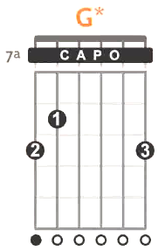
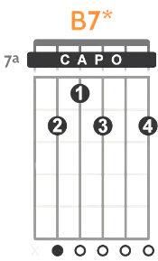
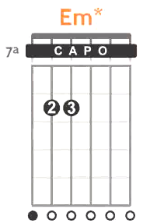
Tab Guitar 3 Chorus-1
C
B |------------0-0-0---0-0---------------------
F#|--------1---1-1-1---1-1---------------------
D |------0---0-0-0-0---0-0---------------------
A |----2-------2-------------------------------
E |--3---------3-----3-------------------------
B |--------------------------------------------

G B7
B |------------3-3-3---3-3--------------2------
F#|------------0-0-0---0-0----------0---0------
D |--------0---0-0-0---0-0--------2---2-2------
A |------0---0-0-----0----------1-------1-1----
E |----2-------2--------------2---------2------
B |--3-----------------------------------------

Em
B |--------------------------------------------
F#|--------0-----0----------0-----0------------
D |------0-----0----------0-----0--------------
A |----2-----2-----2----2-----2-----2----------
E |--------------------------------------------
B |--0----------------0------------------------

Tab Guitar 3 Chorus-1 lanjutan

C
B |------------0-0-0---0-0---------------------
F#|--------1---1-1-1---1-1---------------------
D |------0---0-0-0-0---0-0---------------------
A |----2-------2-------------------------------
E |--3---------3-----3-------------------------
B |--------------------------------------------

G
B |------------3-3-3---3-3---------------------
F#|------------0-0-0---0-0---------------------
D |--------0---0-0-0---0-0---------------------
A |------0---0-0-----0-------------------------
E |----2-------2-------------------------------
B |--3-----------------------------------------

C B7
B |------------0-0-0---0-0------------2--------
F#|--------1---1-1-1---1-1---------0--0--------
D |------2---2-2-2-2---2-2-------2----2--------
A |----2-------2---------------1------1--------
E |--0---------0-----0-------2--------2--------
B |--------------------------------------------

Lagu Bag-2

Bait-3:
Guitar 1 Diam
Tab Guitar 2 sama dengan Tab Intro Bag-4
Tab Guitar 3 sama dengan Tab Lagu Bag-1

Bm F#7
Her mind is Tiffany-twisted, She got the Mercedes-Benz
A E
She got a lot of pretty, pretty boys That she calls friends
G D
How they dance in the courtyard, Sweet summer sweat
Em F#7
Some dance to remember, Some dance to forget

Bait-4:
Guitar 1 Fill Tab
Tab Guitar 2 sama dengan Tab Intro Bag-4
Tab Guitar 3 sama dengan Tab Lagu Bag-1

Bm F#7
So I called up the Captain, Please bring me my wine, he said
e|--------------------------------------------------------------------
B|-3--------------------------5-5h7-------------------------5-5h7----
G|-4--------------------------6-6h7-6-----------------------6-6h7-6--
D|----------------------------------8-----------------------------7--

A E
We haven't had that spirit here since, Nineteen sixty-nine
e|-------------------------------------------------------------------
B|-------------------------------3-3/5----------------------2-2h3----
G|-------------------------------4-4/6-4--------------------2-2h4-3--
D|-------------------------------------6--------------------------4--
G D
And still those voices are calling from far away
e|-----------------------------------------------------------
B|----------------------------------------2-2h3--------------
G|----------------------------------------2-2h4-2------------
D|----------------------------------------------4------------
Em F#7
Wake you up in the middle of the night, Just to hear them say
e|--------------0-----------0-------0----------------2-------
B|----------2---0---0-----0-------0----------2---2-----------
G|------------3---0-----2-------4----------3---3---3---------
D|--------------------4-------5------------------------------
A|---------------------------------------4-------------------
E|-------------------------------------2---------------------

Chorus-2 :

Tab Guitar 1 Fill
D
Welcome to the Hotel California,
e|--------------------------------------------9--9-—9\7--7-7\5--5-5-
B|-------------------------------------------10-10-10\8--8-8\5--7-7-
G|-----4-6-7--------------------------------------------------------
D|-4h8--------------------------------------------------------------
F#7
2a. Such a lovely place, Bm
(Such a lovely place), Such a lovely face
e|------------2--3-5-7--
B|------3--5------------
G|----------------------
D|------------0--2-4-5--
A|------2--4------------
D
2b. We're livin' it up at the Hotel California
e|-----------7-7-7\5--5-5\2--2--
B|-----------8-8-8\7--7-7\3--3--
G|------------------------------
D|------------------------------
Em F#7
2c. What a nice surprise, Bring your alibis
e|-----------0----------0--------0-----------
B|---------0----------0--------0-------------
G|-------0-----0----2--------4-----4---------
D|-----3----------4--------5-----------------

Tab Guitar 2 sama dengan Tab Chorus-1 (1a, 1b, 1c)
Tab Guitar 3 sama dengan Tab Chorus-1

Lagu Bag-3

Bait-5:
Hanya Guitar tanpa Percussi
Guitar 1, 2 dan 3 Mainkan Petikan, semua sama dengan Intro bag-3/4

Bm F#7
Mirrors on the ceiling, The pink champagne on ice,
A E
and she said “We are all just prisoners here Of our own device”
G D
And in the master's chambers They gathered for the feast
Em F#7
The stab it with their steely knives But they just can't kill the beast

Bait-6:
Tab Guitar 1 Fill

Bm F#7
Last thing I remember, I was Running for the door
e|---------------------7\6-7------------------------------6\5-6--
B|---------------------7\6-7------------------------------7\6-7--
G|---------------7-----------------------------------6-----------
D|---------------9-----------------------------------8-----------
A E
I had to find the passage back To the place I was before
e|------------------5\4-5---------------------------------4\3-4--
B|------------------5\4-5---------------------------------5\4-5--
G|-------------6--------------------------------------4----------
D|-------------7--------------------------------------6----------
G D
Relax, said the night man We are programmed to receive
e|---------------------3\2-3-----------------------------2\1-2--
B|---------------------3\2-3-----------------------------3\2-3--
G|-----------------4----------------------------------2----------
D|-----------------5----------------------------------4----------
Em F#7
You can check out any time you like But you can never leave
e|--------------------------------------------------------2---2--
B|---------------------------------5\4-5----------2-----2-----2--
G|----------------------------0----4\3-4--------3-----3-------3--
D|----------------------------2---------------4-----4---------4--
A|------------------------------------------4-----------------4--
E|----------------------------------------2-------------------2--

Tab Guitar 2 sama dengan Intro Bag-3/4
Tab Guitar 3 sama dengan Intro Bag-3

Outro-1 :
Tab Guitar 1 Solo ke-4,

Bm F#7
e|---------------------------------7--5--3--2-------------------
B|---------------------------------7--5--3--2-------------------
G|----------9~ ~ 9-9-9-9-7-6-9-7-6-7--6--4--3-------------------
D|--8-9-11------------------------------------------------------
A|--------------------------------------------------------------
E|--------------------------------------------------------------

A E7
e|--9-10-12-12-12-12~ ~ 12-11-10----11-10-----------------------
B|-------------------------------12-------12-10-9---------------
G|------------------------------------------------9-------------
D|--------------------------------------------------9-----------
A|----------------------------------------------------9h11------
E|--------------------------------------------------------------

G D Em F#7
e|-----------------------------------------0-0-----2-------------
B|------------------------------------------0-0-----2------------
G|--------------------------2h3-2-4p2--------0-0-----3-----------
D|--------------2---4-2-5-4-----------4-------2-2-----2----------
A|--------2-5-4---5------------------------------2-----4---------
E|--2-3-5-----------------------------------------0-----2--------

Tab Guitar 2 sama dengan Intro Bag-3
Tab Guitar 3 sama dengan Intro Bag-3

Outro-2:

Tab Guitar 1, Petikan

Bm F#7 A E7
E|------------2---------------2--|------------5---------------0-
B|--------3-----3---------2------|--------2-----2---------0-----
G|------4---4-----------3---3----|------2---2-----------1---1---
D|----4---------------2----------|----2---------------0---------
A|--2----------------------------|--0---------------------------
E|------------------2------------|------------------0-----------

G D Em F#7
E|------------------------2---2----|----------------------------2-
B|------------3---------3-------3--|--------0---0-----------2-----
G|--------4-----4-----2-----2------|------0---0---0-------3---3---
D|------5---5-------0--------------|----2---------------2---------
A|----5----------------------------|------------------------------
E|--3------------------------------|--0---------------2-----------

Tab Guitar 2 Solo ke-5

Bm F#7
E|---------------------------------------------------------------
B|------------------5-6-7h8p7p5-7-----7-7h8p7\5-5h7p5\3-3h5p3\2--
G|--4-4h6p4\3-4-6-7---------------7-9----------------------------
D|---------------------------------------------------------------
A E7
E|-------0-7-9-7----14-------------------------------------------
B|-----2---------11----------7-7-7-5-5-5--------------3-3h5p3\2--
G|-4-3-----------------------------------7-7-6-4-----------------
D|---------------------12\7----------------------7-6-------------
G
E|----------0---------------------------------------3------------
B|--2h3p2p0-------------------------------------3-5--------------
G|------------2-1-----------------4-4h6p4-3-4-6------------------
D|----------------2-4-5h7p5p4-5-7--------------------------------
D
E|--3/5-5-5-5h7-5-3-3/5------------------------------
B|--5/7-7-7-7/8-7-5-5/7------------------0h2h3h4-----
G|-------------------------------0h2h3h4-------------
D|-----------------------0h2h3h4---------------------
Em
E|--------3p0---7p3---10p7---12p10-------------------
B|--5p0-------0-----0------8-------12\---------------
G|------0--------------------------------------------
D|---------------------------------------------------
F#7 Bm
E|--2-2h3p2p0---0h2-0----------------7-6-7-9---------||
B|------------3-------3-2h3p2p0-2----3-2-3-5---------||
G|---------------------------------------------------||
D|---------------------------------------------------||

Tab Guitar 3 sama dengan Tab Intro Bag-3

Outro-Final
SOLO DUEL antara Guitar 1 dan Guitar 2
Tab Guitar 3 Mainkan Petikan

Bm F#
e|--7-6-7-9-10p7---10p7---10p7---10p7---10p7---9p6---9p6---9p6--14---
B|---------------7------7------7------7------7-----7-----7-----------
G|-------------------------------------------------------------------
D|-------------------------------------------------------------------

e||--------------------------------------------------------------4/6-
B||--3p2-3-5-7p3----7p3----7p3----7p3----7p3----5p2---5p2---5p2------
G||---------------4------4------4------4------4-----3-----3----------
D||------------------------------------------------------------------

A E
E|--9p5---9p5---9p5---9p5---9p5---7p4---7p4---7p4---12----------
B|------5-----5-----5-----5-----5-----5-----5-------------------
G|--------------------------------------------------------------
D|--------------------------------------------------------------

E|--------------------------------------------------2/4---------
B|--5p2---5p2---5p2---5p2---5p2---3p0---3p0---3p0---------------
G|------2-----2-----2-----2-----2-----1-----1-------------------
D|--------------------------------------------------------------
G D
E|-7p3---7p3---7p3---7p3---7p3---5p2---5p2---5p2---10-----------
B|-----3-----3-----3-----3-----3-----3-----3--------------------
G|--------------------------------------------------------------
D|--------------------------------------------------------------

E|--------------------------------------------------------------
B|--3-----3-----3-----3-----3-----3-----3-----3---3/7-----------
G|----4-----4-----4-----4-----4-----2-----2-----2---------------
D|------5-----5-----5-----5-----5-----4-----4-------------------

Em
E|--3p0---3p0---3p0---3p0---3p0----------------------
B|------0-----0-----0-----0-----0--------------------
G|---------------------------------------------------
D|---------------------------------------------------

E|---------------------------------------------------
B|---------------------------------------------------
G|--4p0---4p0---4p0---4p0---4p0----------------------
D|------2-----2-----2-----2-----2--------------------

F# Bm
E|------0-----2-----6-----7--------------7--7--7--7--
B|--2h3---2-----3-----7-----7-------7-11----------7--
G|----------3-----4-----9-----7-7-9---------------7--
D|------------------------------------------------9--
A|------------------------------------------------9--
E|------------------------------------------------7--
Bm
E|------------------------2-----------0--2--2--2--2--
B|------2-----3-----5p2-----3-2-3p2-3----3--3--3--3--
G|--3h4---3-----3-------3----------------4--4--4--4--
D|----------4-----4----------------------4--4--4--4--
A|---------------------------------------2--2--2--2--
E|---------------------------------------------------

