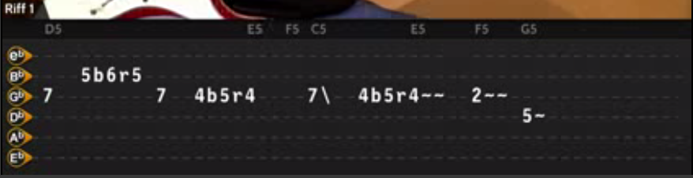
SOLO-1
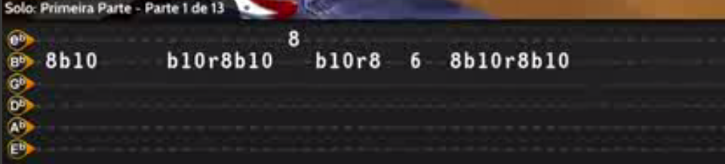
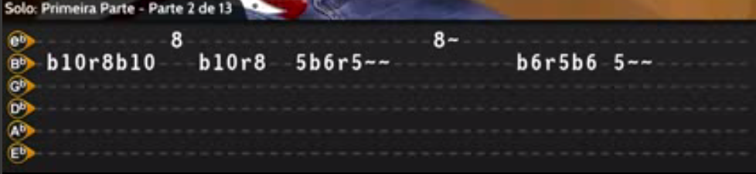
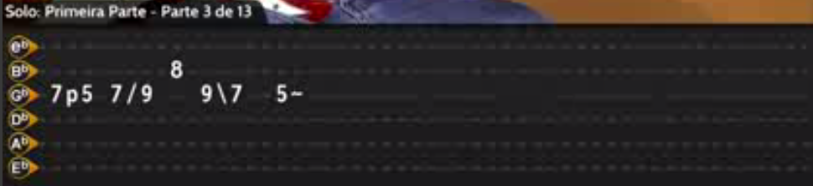

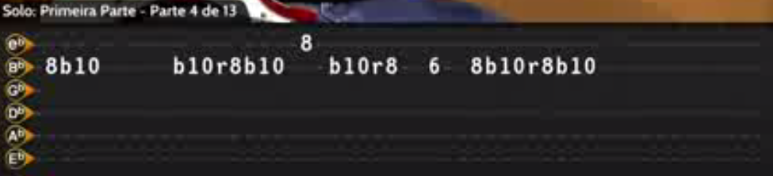
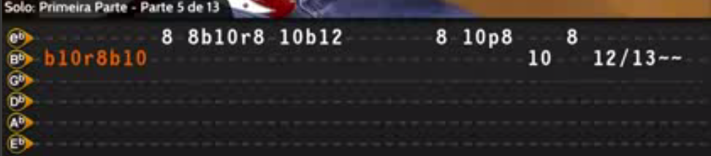

November Rain
GunsN’Roses

Tom: C
Afinação: Eb Ab Db Gb Bb Eb

F7M Dm7
When I look into your eyes
C
I can see a love restrained
F7M Dm7
But darling when I hold you
C
Don't you know I feel the same

Dm G
Nothing lasts forever
C
And we both know hearts can change
Dm G
And it's hard to hold a candle
C
In the cold november rain

F7M Dm7
We've been through this such a long, long time
C
Just trying to kill the pain, oh yeah

F7M
But lovers always come, And lovers always go
Dm7 C
An no one's really sure Who's letting go today walking away

F7M
If I could take the time to lay it on the line
Dm7 C
I could rest my head just knowing that you were mine, all mine

Dm G
So if you want to love me
C
Then darling don't refrain
Dm G
Or I'll just end up walking
C
In the cold november rain

Primeiro Refrão:

F G
Do you need some time, on your own
F G
Do you need some time, all alone
F G
Everybody needs sometime, on their own
F G
Don't you know you need sometime, all alone

E5 F5 C5
I know it's hard to keep an open heart
E5 F5 D5 (Riff 1)
When even friends seem out to harm you
E5 F5 C5
But if you could heal a broken heart
E5 F5 G5
Wouldn't time be out to charm you

Riff 1:

D5 E5 F5 C5 E5 F5 G5
E|---------------------------------------------------
B|----5b6r5------------------------------------------
G|-7--------7--4b5r4~~------7-----4b5r4~~--2~~--0---
D|----------------------------------------------5-----
A|---------------------------------------------------
E|---------------------------------------------------

Solo - Primeira Parte:

E|-------------------8-------------------------------
B|-8b10-----b10r8b10---b10r8--6--8b10r8b10~~---------
G|---------------------------------------------------
D|---------------------------------------------------
A|---------------------------------------------------
E|---------------------------------------------------

E|----------8------------------8~--------------------
B|-b10r8b10---b10r8--5b6r5~~---------b6r5b6-5~~------
G|---------------------------------------------------
D|---------------------------------------------------
A|---------------------------------------------------
E|---------------------------------------------------

E|---------------------------------------------------
B|---------8-----------------------------------------
G|-7p5-7/9---97~-5----------------------------------
D|---------------------------------------------------
A|---------------------------------------------------
E|---------------------------------------------------

E|-------------------8-------------------------------
B|-8b10-----b10r8b10---b10r8--6--8b10r8b10~~---------
G|---------------------------------------------------
D|---------------------------------------------------
A|---------------------------------------------------
E|---------------------------------------------------

E|----------8-8b10r8-10b12~------8-10p8----8---------
B|-b10r8b10-----------------------------10---12/13~~-
G|---------------------------------------------------
D|---------------------------------------------------
A|---------------------------------------------------
E|---------------------------------------------------

E|-13p12----13p12----13b15--13~-10-12-13-12h13p12p10-
B|-------13-------13---------------------------------
G|---------------------------------------------------
D|---------------------------------------------------
A|---------------------------------------------------
E|---------------------------------------------------

E|-10-12-13b15---13-12-13b¼-12~~-19b20~~~------------
B|---------------------------------------------------
G|---------------------------------------------------
D|---------------------------------------------------
A|---------------------------------------------------
E|---------------------------------------------------

E|-19-19-19p1715-17-17p15-15-1513-13-1312-12-12---
B|---------------------------------------------------
G|---------------------------------------------------
D|---------------------------------------------------
A|---------------------------------------------------
E|---------------------------------------------------

E|-13p1210--13~~~~------12-13-12-13p12-------12-----
B|--------------------------------------15-13----13--
G|---------------------------------------------------
D|---------------------------------------------------
A|---------------------------------------------------
E|---------------------------------------------------

E|---------------------------------------------------
B|-15-17p15p13-15-12h13-12h13p12h13p12-------12------
G|-------------------------------------14-12----12---
D|---------------------------------------------------
A|---------------------------------------------------
E|---------------------------------------------------

E|---------------------------------------------------
B|--------------------------------13~~---------------
G|-14-10h12p109h10p9~~~~-12p10p9------10h12p10p9-10-
D|---------------------------------------------------
A|---------------------------------------------------
E|---------------------------------------------------

E|----------------------------15---------------------
B|-13~~---------------15b17------b17r15-13~~~b15~~---
G|------10h12p10p9-10--------------------------------
D|---------------------------------------------------
A|---------------------------------------------------
E|---------------------------------------------------

Refrão:
(Continuação Solo)

E|---------------------------------------------------
B|-----------5b6r5-----------------------------------
G|---5-7-5---------5--------------5-7----------------
D|-7-------7---------7~~~-------------5h7-5~~--------
A|---------------------------------------------------
E|---------------------------------------------------

E|---------------------------------------------------
B|-6b8-------b6r5------------------------------------
G|----------------5-----------------5h7~~------------
D|------------------7~~-----------5------------------
A|---------------------------------------------------
E|---------------------------------------------------

E|---------------------------------------------------
B|------------5b6r5----------------------------------
G|---5h7p5----------5---------------5/7----9----10---
D|-5-------7----------7~~---------5------------------
A|---------------------------------------------------
E|---------------------------------------------------

E|---------------------------------------------------
B|---------------------------------------------------
G|-12----14----16----17---19-------------------------
D|---------------------------------------------------
A|---------------------------------------------------
E|---------------------------------------------------

F G
Do you need some time, on your own
F G
Do you need some time, all alone
F G
Everybody needs sometime, on their own
F G
Don't you know you need sometime, all alone

Solo - Segunda Parte:

E|---------------20-----------------20---------------
B|-18~~---20b22------b22r20~~~~b22------17b18-17~~---
G|---------------------------------------------------
D|---------------------------------------------------
A|---------------------------------------------------
E|---------------------------------------------------

E|-19b20~~~------------------------------------------
B|---------------------------------------------------
G|---------------------------------------------------
D|---------------------------------------------------
A|---------------------------------------------------
E|---------------------------------------------------

E|-----------------------15-17----15-17p1513-15-----
B|-b18r17b18~~--15-17-18-------18--------------------
G|---------------------------------------------------
D|---------------------------------------------------
A|---------------------------------------------------
E|---------------------------------------------------

E|-12b13--12----------------------------15-----------
B|------------15b17r15--13-15-13----13-----13--13~~--
G|-------------------------------14------------------
D|---------------------------------------------------
A|---------------------------------------------------
E|---------------------------------------------------

E|-------15-----------------15b17-15~--13-15p13-12---
B|----13----13--13~~-----13--------------------------
G|-14-----------------14-----------------------------
D|---------------------------------------------------
A|---------------------------------------------------
E|---------------------------------------------------

E|-13-12h13p12----12--------15-----------------------
B|-------------15----15b17------b17r15~--13~~--------
G|---------------------------------------------------
D|---------------------------------------------------
A|---------------------------------------------------
E|---------------------------------------------------

F7M Dm7
And when your fears subside
C
And shadows still remain
F7M Dm7
I know that you can love me
C
When there's no one left to blame

Dm G
So nevermind the darkness
C
We still can find a way
Dm G
'Cause nothing lasts forever
C
Even cold november rain

( C5 G/B A5 G5 F5 G5 ) (2x)
( C5 )

Final: C5 G5 F5 Eb5 Ab5 Bb5 C5

Solo Final:

E|-19b20---19~~-20-20b22--20-19-20-15----15-16~~-----
B|------------------------------------16-------------
G|---------------------------------------------------
D|---------------------------------------------------
A|---------------------------------------------------
E|---------------------------------------------------

E|-16p1513-15~~----13-15-16-15-16p15p13----------13-
B|---------------------------------------16-13-16----
G|---------------------------------------------------
D|---------------------------------------------------
A|---------------------------------------------------
E|---------------------------------------------------

E|-15p13----13-------13-13---------------------------
B|-------16----15-16-------15b16-15b16-15b16r15-13---
G|---------------------------------------------------
D|---------------------------------------------------
A|---------------------------------------------------
E|---------------------------------------------------

E|-------13------------------------------------------
B|-15-16----15-16-18-16-15h16p15---------------------
G|-------------------------------17~-----------------
D|---------------------------------------------------
A|---------------------------------------------------
E|---------------------------------------------------

(Parte 2)

E|-19b20---19~~-20-20b22--20-19-20-15----15-16~~-----
B|------------------------------------16-------------
G|---------------------------------------------------
D|---------------------------------------------------
A|---------------------------------------------------
E|---------------------------------------------------

E|-16p1513-15~~-------------13h16p13h15p13----13----
B|------------------13h15h16----------------16----15-
G|---------------------------------------------------
D|---------------------------------------------------
A|---------------------------------------------------
E|---------------------------------------------------

E|---------------------------------------------------
B|-16-15h16p15p13----13------------------------------
G|----------------15----15-13h15p13p12h13p12h13p12---
D|---------------------------------------------------
A|---------------------------------------------------
E|---------------------------------------------------

E|---------------------------------------------------
B|--------------------------------13-----------------
G|-h13p12h13p12h13p12h13p12h13h15----15-13-12h13p12--
D|---------------------------------------------------
A|---------------------------------------------------
E|---------------------------------------------------

E|----------------------------13----------------13---
B|--------13h1516p15p13h15h16----16p15p13h15h16------
G|-h13h15--------------------------------------------
D|---------------------------------------------------
A|---------------------------------------------------
E|---------------------------------------------------

E|-h15h16p15p13----13--------------------------------
B|--------------16----15-16-15h16p15p13~-------------
G|---------------------------------------------------
D|---------------------------------------------------
A|---------------------------------------------------
E|---------------------------------------------------
(Parte 3)

E|-19b20---19~~-20-20b22--20-19----------------------
B|------------------------------15b16--b16r15p14p13--
G|---------------------------------------------------
D|---------------------------------------------------
A|---------------------------------------------------
E|---------------------------------------------------

E|----------------------------------------------20~~-
B|-15b16~-b16r15p14p13-16b17r16b19r------------------
G|----------------------------------------16/17------
D|---------------------------------------------------
A|---------------------------------------------------
E|---------------------------------------------------

E|-20-19-20-16-19-16-18p16----16---------------------
B|-------------------------20----18h20p18p16--20p18--
G|---------------------------------------------------
D|---------------------------------------------------
A|---------------------------------------------------
E|---------------------------------------------------

E|---------------------------------------------------
B|-20p18--20p18--20p18-------------------------------
G|---------------------------------------------------
D|---------------------------------------------------
A|---------------------------------------------------
E|---------------------------------------------------

(Parte 4)

E|-19b20---19~~-20-20b22--20-19-20-15----15-16~~-----
B|------------------------------------16-------------
G|---------------------------------------------------
D|---------------------------------------------------
A|---------------------------------------------------
E|---------------------------------------------------

E|---------------------15----18b20-18b20~~--18p15----
B|-16p1513-15~~----15----15----------------------18-
G|---------------------------------------------------
D|---------------------------------------------------
A|---------------------------------------------------
E|---------------------------------------------------

E|-15------------------------------------------------
B|----18p16------------------------------------------
G|----------15~~---17p15----15-----------------------
D|-----------------------17----17-18-17h18p17p15-----
A|-----------------------------------------------18--
E|---------------------------------------------------

E|---------------------------------------------------
B|---------------------------------------------------
G|---------------------------------------------------
D|-15------------------------------------------------
A|----17h18p17p15~~----------------------------------
E|---------------------------------------------------

(Parte 5)

E|-19b20---19~~-20-20b22--20-19-20-15----15-16~~-----
B|------------------------------------16-------------
G|---------------------------------------------------
D|---------------------------------------------------
A|---------------------------------------------------
E|---------------------------------------------------

E|-16p1513-15~~----13-15-16b18r16b18-15-16p15p13----
B|------------------------------------------------16-
G|---------------------------------------------------
D|---------------------------------------------------
A|---------------------------------------------------
E|---------------------------------------------------

E|---------------------------------------------------
B|-15h16p15p13h15p13----13-15h16p15p13-15p13-15p13---
G|-------------------15------------------------------
D|---------------------------------------------------
A|---------------------------------------------------
E|---------------------------------------------------

E|-------13-15b16r15~~-------------------------------
B|-15-16-----------------15b16r15~~------------------
G|---------------------------------------------------
D|---------------------------------------------------
A|---------------------------------------------------
E|---------------------------------------------------

(Parte 6)

E|-19b20---19~~-20-20b22--20-19-20-15----15-15b16~~--
B|------------------------------------16-------------
G|---------------------------------------------------
D|---------------------------------------------------
A|---------------------------------------------------
E|---------------------------------------------------

E|-15p1311-13b15~~----------------------------------
B|-------------------------16--15b16r15~~~-----------
G|-----------------------x---------------------------
D|---------------------x-----------------------------
A|---------------------------------------------------
E|---------------------------------------------------

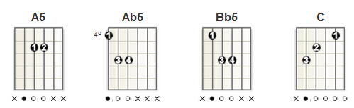
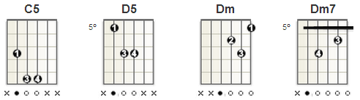

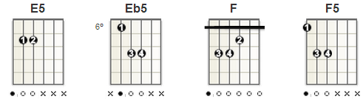

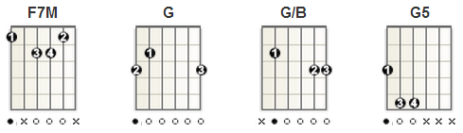

November Rain
BASS TAB :

Gb------------------------I
Db-3----2--0--------------I
Ab--------------3------3--I
Eb-------------------3----I (x 2)

Gb-----------0-0-0-0-0---------------------I
Db-0-0-0-0-0-------------------------------I
Ab---------------------3-3-3-3-3-3-3-3-3-3-I
Eb-----------------------------------------I

Gb------------------------------------------I
Db-0-0-0-0-0--------------------------------I
Ab----------------------3-3-3-3-3-3-3-3-3-3-I
Eb------------3-3-3-3-3---------------------I

Gb------------------------I
Db-3----2--0--------------I
Ab--------------3------3--I
Eb-------------------3----I

Gb------------------------------------------I
Db-0-0-0-0-0--------------------------------I
Ab----------------------3-3-3-3-3-3-3-3-3-3-I
Eb------------3-3-3-3-3---------------------I
Guitar Only Bit

Gb--------------------------------------I (You know it's hard..
Db-2-2--3-3-----------2-2--3-3--0-0-0-0-I
Ab-----------3-3-3-3--------------------I
Eb--------------------------------------I

Gb------------------------------0-0-0-0-0-0-0-0-I
Db-2-2--3-3-----------2-2--3-3------------------I
Ab-----------3-3-3-3----------------------------I
Eb----------------------------------------------I

Gb-------------------------------------------I
Db-3-3-3-3--2---0-0-0-0----------------------I
Ab-----------------------3-3-3-3-3-3-3-3-3-3-I
Eb-------------------------------------------I (2x)

Gb------------0-0-0-0-0----------------------I
Db-0-0-0-0-0---------------------------------I
Ab-------------------------------------------I
Eb-----------------------3-3-3-3-3-3-3-3-3-3-I (2x)

Gb------------------------------0-0-0-0-0-0-0-0-I
Db-2-2--3-3-----------2-2--3-3------------------I
Ab-----------3-3-3-3----------------------------I
Eb----------------------------------------------I

Gb-------------------------------------------I
Db-3-3-3-3--2---0-0-0-0----------------------I
Ab-----------------------3-3-3-3-3-3-3-3-3-3-I
Eb-------------------------------------------I(2x)

Gb------------0-0-0-0-0----------------------I
Db-0-0-0-0-0---------------------------------I
Ab-------------------------------------------I
Eb-----------------------3-3-3-3-3-3-3-3-3-3-I (2x)

Guitar Only Bit
Gb-0-0-0-0-0-0-0-0-0-0-0-0-0-0-0-0--I
Db----------------------------------I
Ab----------------------------------I
Eb----------------------------------I

Gb-------------------------------------------I
Db-3-3-3-3--2---0-0-0-0----------------------I
Ab-----------------------3-3-3-3-3-3-3-3-3-3-I
Eb-------------------------------------------I(x 2)
Gb------------------------I
Db-3----2--0--------------I
Ab--------------3------3--I
Eb-------------------3----I(x 2)

Gb--------0--0-------------------I
Db--0--0-------------------0--0--I
Ab---------------3------3--------I
Eb-------------------3-----------I

Gb-5-5--4-4--2-2--0-0-----------0-0-0-0-0-0-0-0--I
Db--------------------3-3-3-3-3------------------I
Ab-----------------------------------------------I
Eb-----------------------------------------------I(2x)

Gb-5----5-5--3--5-5--1-1--3-3-3-3-3--I
Db-----------------------------------I
Ab-----------------------------------I
Eb-----------------------------------I

Gb-5-5--3--5-5---1-1--3-3-3-3-3-I
Db------------------------------I
Ab------------------------------I
Eb------------------------------I(2x)

Gb-5-5-5--0-0-0----------------1-1-1--3-3-3---5-5-5-5-5-5-5-5-5-5-5-5-5-5-5-I
Db---------------3-3-3--1-1-1-----------------------------------------------I
Ab--------------------------------------------------------------------------I
Eb--------------------------------------------------------------------------I

Gb-0-0-0----------------1-1-1--3-3-3--5-5-5-5-5-5-5-5-5-5-5-5-5-5-5-I
Db--------3-3-3--1-1-1----------------------------------------------I
Ab------------------------------------------------------------------I
Eb------------------------------------------------------------------I (4x)

Gb-0-0-0----------------1-1-1--3-3-3--5--I
Db--------3-3-3--1-1-1-------------------I
Ab---------------------------------------I
Eb---------------------------------------I

