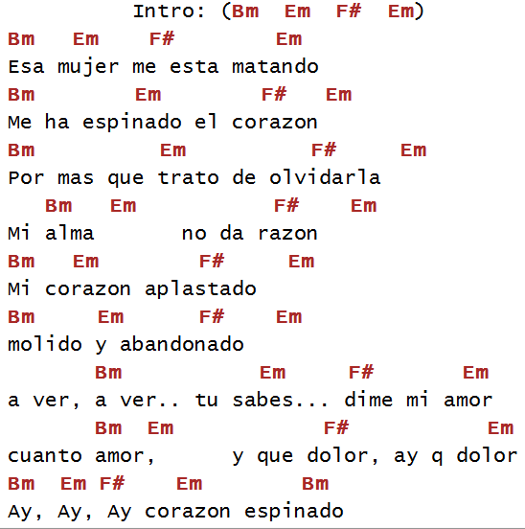
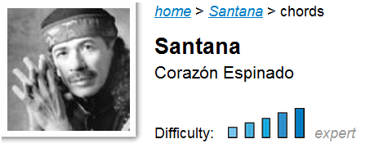

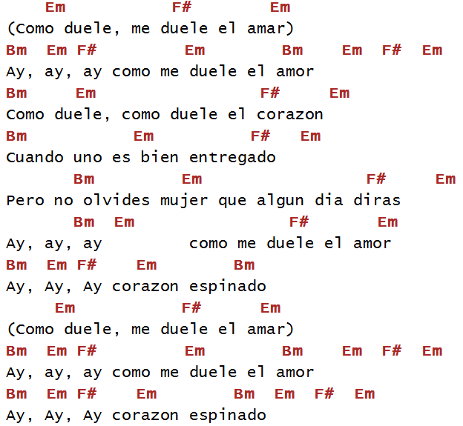

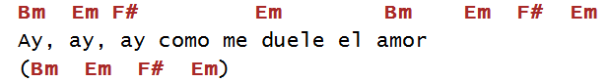

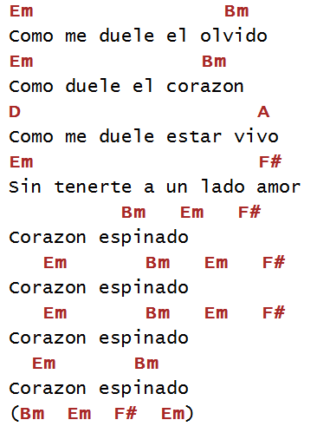

Corazon Espinado Santana & Mana
ALBUM:Supernatural

Tablature explanation:
h = hammer on
p = pull off
^ = bend two semitones
b = bend one semitone
r = release bend
/ = slide up
\ = slide down
//////// = turbo pick the preceding note (is there a proper name for this teqnique?)

tab by jordanlockert@yahoo.com
...one of my favorites from supernatural. Musically, this song is very much like smooth.
Its just two semitones higher. You can take licks and fill from this song and put them
in smooth by lowering them the 2 frets, or vice versa.

Intro
-|----------------------------7-6-----------------------------|
-|--------------------------7------7--------------------------|
-|-----4h7p4---4---------/7----------9--7-9^9^--------9-6-7-9-|
-|-4h7-------7------------------------------------------------|
-|------------------------------------------------------------|
-|------------------------------------------------------------|

-|------7h10p7----7------------14-17^r--14-----------14------14----14--
-|-7h10--------10----------/17-------------17--15-17^----17^----17^----
-|---------------------------------------------------------------------
-|---------------------------------------------------------------------
-|---------------------------------------------------------------------
-|---------------------------------------------------------------------

--------------------------------|
--17-14-15-17---15-14-14--------|
--------------------------16----|
--------------------------------|
--------------------------------|
--------------------------------|...espinado el corazon
-|------------------------|
-|-10----------7----------|
-|-9^--9p7-9-7---7--------|
-|-----------------9------|
-|------------------------|
-|------------------------|

...no da razon
-|-------------------|
-|-------------------|
-|-6-7-9---9p7p6-----|
-|--------------9----|
-|-------------------|
-|-------------------|

...corazon aplastado
-|-5-------------------------|
-|---8-7-5---5----7p5h7------|
-|---------7-----------------|
-|---------------------------|
-|---------------------------|
-|---------------------------|

...Aber aber
-|--------------|
-|--------------|
-|---4-6-7------|
-|-4------------|
-|--------------|
-|--------------|

Chorus:...como me duele el amor
-|-------------------------------------------------|
-|-10^///////-10^///////-10^--10p7---7---7---------|
-|---------------------------------9---9---9^------|
-|-------------------------------------------------|
-|-------------------------------------------------|
-|-------------------------------------------------|

...nostiene entregados
-|--------------|
-|--------------|
-|-6-7-9--------|
-|--------------|
-|--------------|
-|--------------|
Hay ya yay como me duele el amor
-|------------------------------------------|
-|------------------------------------------|
-|---7-7-7------------7---7-----------------|
-|-9^---------------9^--9^--7-9p7-----------|
-|-------------------------------9----------|
-|------------------------------------------|

Chorus:
...como me duele el amor
-|--------------------------------7-----------------------|
-|-10^-----10--7--10-7h10p7---7-----10p7-----7------------|
-|--------------------------9---9^-------9p7---7----------|
-|-----------------------------------------------9--------|
-|----this is the best I could figure this one out...-----|
-|--------------------------------------------------------|

-|------------------------------------------------------
-|-----------------------17p15-17p15-17p15-17p15-17^----
-|-----7---6----7-6-------------------------------------
-|-9----------------9-9---------------------------------
-|------------------------------------------------------
-|------------------------------------------------------
ah ah ah...
-12----12-12------------------------------------------|
----17^------15-17p15------15--14----15-14------------|
-----------------------16------------------16-16----\-|
------------------------------------------------------|
------------------------------------------------------|
------------------------------------------------------|
ah ah ah...
-|-------------------------------2////////*-------|
-|-------------------------------3////////*-------|
-|------------------------------------------------|
-|------------------------------------------------|
-|-/9-9-9-----------------------------------------|
-|------------------------------------------------|
*slide up while rapid picking
-|----------------------------------------------------------
-|-12----------------------------14br-12-----12//////-------
-|---------14-11----11-11----------------14^----------14p11-
-|---------------14^----------------------------------------
-|----------------------------------------------------------
-|----------------------------------------------------------
solo
---------------------|
---------------------|
---------------------|
-14^-14---12h14------|
---------------------|
---------------------|

-|----------------------------------------------------------14///////-
-|-12-15-15-12-15-12-15-15-12---14-17-17-14-17-14-17-17-14------------
-|--------------------------------------------------------------------
-|--------------------------------------------------------------------
-|--------------------------------------------------------------------
-|--------------------------------------------------------------------

-14t15*----14-15-14-15-14-15-14-15-17-15-14-17^-|
------------------------------------------------|
------------------------------------------------|
------------------------------------------------|
------------------------------------------------|
------------------------------------------------|

*trill about maybe 8 times. Listen to song to hear it.
-|-17^-----17-14----14-14----
-|---------------17^---------
-|---------------------------
-|---------------------------
-|---------------------------
-|---------------------------

-17^-17^-17^rp14--14-------------14---------------|
----------------17--17b-17p15h17---15-17--15p14---|
-----------------------------------------------16-|
--------------------------------------------------|
--------------------------------------------------|
--------------------------------------------------|
-|----------------------------------------------------------------
-|-15p14p12-15p14p12-15p14p12-15p14p12-15p14p12-15p14p12-15p14p12-
-|----------------------------------------------------------------
-|----------------------------------------------------------------
-|----------------------------------------------------------------
-|----------------------------------------------------------------

-------------------------------------------------------|
-17p15p14-17p15p14-17p15p14-17p15p14-17p15p14-17p15p14-|
-------------------------------------------------------|
-------------------------------------------------------|
-------------------------------------------------------|
-------------------------------------------------------|

-|-2////////////*--------------------------------------------|
-|-3////////////*--------------------------------------------|
-|-----------------------------------------------------------|
-|-----------------------------------------------------------|
-|-----------------------------------------------------------|
-|-----------------------------------------------------------|
*turbo pick and slide all the way up the fretboard ...el olvido
-|----------------------------------------|
-|----------------------------------------|
-|----------------------------------------|
-|-14-12-11-----------11-11---------------|
-|-----------14-12-14---------------------|
-|----------------------------------------|

...el corazon
-|---7-9---10-9-7----------------|
-|-7----------------7------------|
-|--------------------7----------|
-|----------------------9-7------|
-|-------------------------------|
-|-------------------------------|...estar vivo

-|---------------------------------------------------|
-|---------------------------------------------------|
-|----------------------11-12-12-11h12p11------------|
-|-----11-14-14-11---14-------------------14--12-----|
-|-/12------------12---------------------------------|
-|---------------------------------------------------|

...lado amor
-|-----------------------------|
-|-----------------------------|
-|-----------------------------|
-|-----------------------------|
-|-/9-9-9-/9-9-9-/9-9-9--------|
-|-----------------------------|

Corazon espinado
-|---------------------------------------------------------7-------
-|-------------7-----------------------------------7---------------
-|-----7--9------7---------7--6----7-6--------/7-9---9---9^--9p7h9-
-|-9---------------9-7-9---------------7---9-----------------------
-|---------------------------------------9-------------------------
-|-----------------------------------------------------------------

----------------7----7----7-7-7-7-7-|
-7--------------7----7----7-7-7-7-7-|
--7--------7-9^---9^---9^-----------|
---9p7h9----------------------------|
------------------------------------|
------------------------------------|

-|---------------------12-----------------------------------------
-|-17^------17-15-17^-----17^--12h15p12-12--15p12-12--15p12-12\---
-|----------------------------------------------------------------
-|----------------------------------------------------------------
-|----------------------------------------------------------------
-|----------------------------------------------------------------

---------------------------------14////////------------14-
-14h17-17--14h17-17--14h17-17----15////////15-14-15-17----
----------------------------------------------------------
----------------------------------------------------------
----------------------------------------------------------
----------------------------------------------------------

-17p14-17p14-17p14-17^--17^-17^-17^-rp14--14----------------|
----------------------------------------17--17^-17p15-------|
------------------------------------------------------------|
------------------------------------------------------------|
------------------------------------------------------------|
------------------------------------------------------------|

-|----------------------------------------------------------------------
-|---------15--15-15-14----17-15-14-------------15--14-----15-14--------
-|-16/////--------------------------14----h16--------------------16-16--
-|-16/////-----------------------------16-------------------------------
-|----------------------------------------------------------------------
-|----------------------------------------------------------------------

--------------------------------------------------------------------|
----------------------12--------------------------------------------|
----------11----------------------11-----------------11-------------|
----12-14----14----14^---14p12h14---12---------12-12----14----12h14-|
-14-----------------------------------14----14----------------------|
--------------------------------------------------------------------|

-|----7/////----9/////----10/////----12//-14-14----14----14----14-----
-|-10^-------12^-------13^--------15^-----------17^---17^---17^---17^-
-|--------------------------------------------------------------------
-|--------------------------------------------------------------------
-|--------------------------------------------------------------------
-|--------------------------------------------------------------------

-14-15^-----------14---------------------------------------------|
--------17-15-17^---15------15-------15-------14h17-17-14h17-17--|
----------------------16-16----16-16----16-16--------------------|
-----------------------------------------------------------------|
-----------------------------------------------------------------|
-----------------------------------------------------------------|

Corazon Espinado
Bass Tab
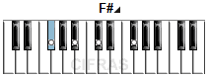
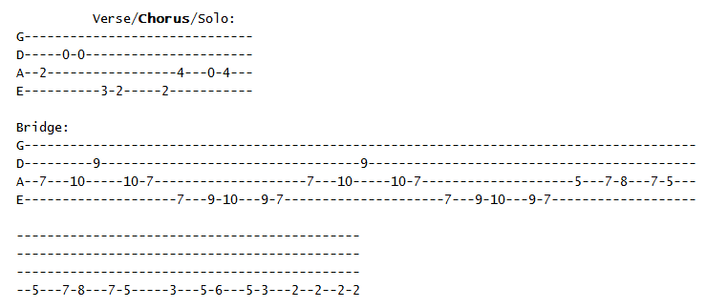
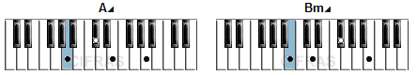

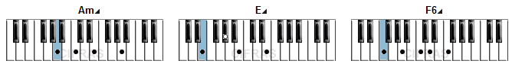

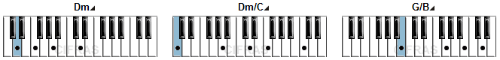

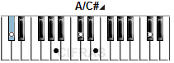
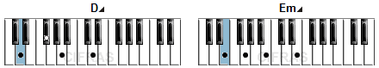
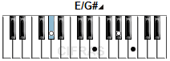
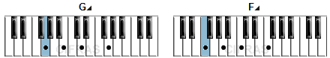

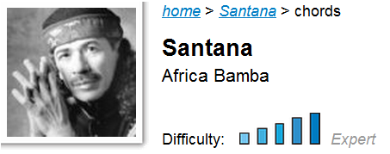

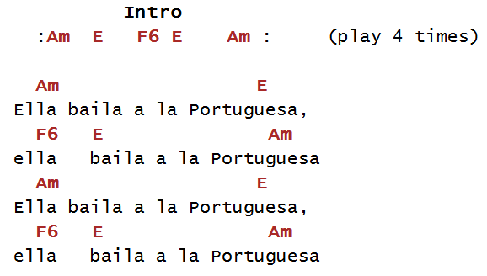

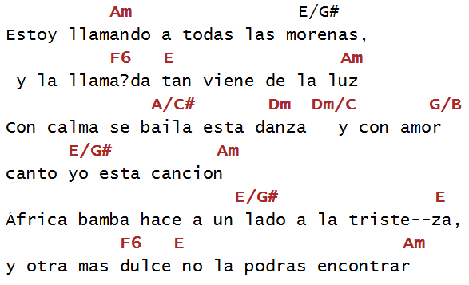

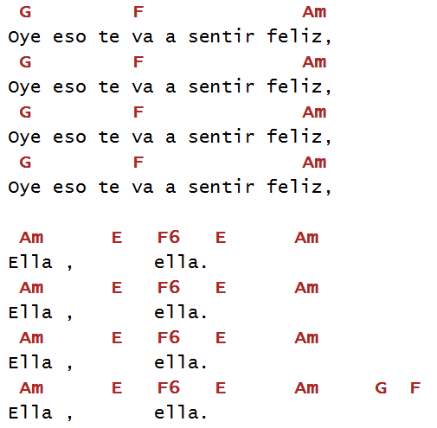

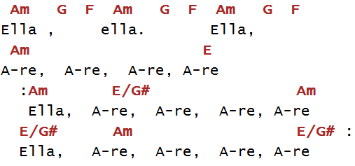

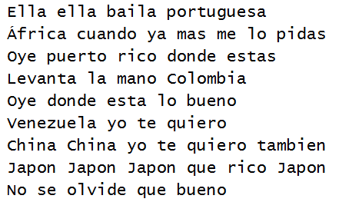

Africa Bamba
Artist: Santana
Album: Supernatural
Transcribed by jordanlockert@yahoo.com

Tablature Explanation:
h=hammer-on
p=pull-off
/=slide up or indicates picking
\=slide down
b=bend «
^=bend full
br, ^r=bend &release

Intro
Classical Guitar
|---------------------------------------------------------------------|
|------------------------10----------------------------------------10-|
|----------7h9-7-9-----9----9-9-7-9-7-----9p7---------7----------9----|
|---7h9h10------------------------------------10-10-9---9-10----------|
|-7-------------------------------------------------------------------|
|---------------------------------------------------------------------|

|---------------------------------------------------------------------------------|
|---8-------------------8-------------------10-10-9-9-----------------------------|
|-9---10-9-7----9-----9---10-9-7---/9-7---------------10-9-7-7----------7---------|
|------------10------------------10----------------------------10-10--9---10-9-7--|
|---------------------------------------------------------------------------------|
|---------------------------------------------------------------------------------|

Electric Guitar
-|-------------------------------------10-10----------------------8---------------------|
-|-12br-10-10-----12br--10-12-13-12-13-------13----13-12-12-10-------10-----------------|
-|-----------------------------------------------------------------------9p7----7h9-9---|
-|---------------------------------------------------------------------------10---------|
-|--------------------------------------------------------------------------------------|
-|--------------------------------------------------------------------------------------|

-|----------------------------10--10--12--12br-13-12-13-15-13-12-13-
-|--10-10-10--12--12--13--13----------------------------------------
-|-9----------------------------------------------------------------
-|------------------------------------------------------------------
-|------------------------------------------------------------------
-|------------------------------------------------------------------

-12h13p12---12------------------------------------------|
---------15----15-15-13-12-13---------------------------|
------------------------------14-14-14-14---------------|
------------------------------------------14-12-14------|
--------------------------------------------------------|
--------------------------------------------------------|

Classical Guitar
...portugueza
-|--7-8-7---------------|---------------------------------------|
-|-10-----10-9----------|-10-12-13--10--13-10-12-13-10-12-13----|
-|-9-----------10-9-7---|---------------------------------------|
-|----------------------|---------------------------------------|
-|----------------------|---------------------------------------|
-|arp-------------------|---------------------------------------|

...portugueza
-|-12///////13-12----12----12-----------------------------------------|
-|----------------15----15----15-13-15--13-13-12-15-13-12-13----------|
-|-----------------------------------------------------------14-14----|
-|--------------------------------------------------------------------|
-|--------------------------------------------------------------------|
-|--------------------------------------------------------------------|

...
...
...
...feliz
-|----8-8-7------------------|-------------------------------------|
-|--10------10---------------|-12br-10-10--------------------------|
-|-9-----------9-7----9-7----|------------12-10-9------------------|
-|-----------------10--------|--------------------12-10-12^r-------|
-|---------------------------|-------------------------------------|
-|---------------------------|-------------------------------------|

...feliz
-|----------------------------------12h13-13p12---12------------------|
-|-------------------------12h13h15------------15----15-15-13--15-----|
-|----------------------14--------------------------------------------|
-|-------------12h14h15-----------------------------------------------|
-|----12h14h15--------------------------------------------------------|
-|-12-----------------------------------------------------------------|

...feliz
-|-------12--------12-------12-------12------|
-|----13-------13--------13-------13---------|
-|-14-----------------14-------14------------|
-|-------------------------------------------|
-|-------------------------------------------|
-|-------------------------------------------|

Classical Guitar

...portugueza
-|---------------------------------|-12-12------------------|-------------------------------|
-|-10-12-12-12--12h13-13/15-15-----|--------13--------------|-12-12-12-12-9-----------------|
-|---------------------------------|-----------14-----------|----------------10-9-----9-----|
-|---------------------------------|--------------14--------|---------------------12--------|
-|---------------------------------|-----------------15-----|-------------------------------|
-|---------------------------------|------------------------|-------------------------------|

...
...
...
...esta danza (Electric)
-|-----------------------|
-|-10-8------------------|
-|-----/9-7----7h9p7-----|
-|----------10-----------|
-|-----------------------|
-|-----------------------|

...cancion
-|----------------------------------12h13-------|
-|-------------------------12h13h15-------------|
-|----------------------14----------------------|
-|-------------12h14h15-------------------------|
-|----12h14h15----------------------------------|
-|-12-------------------------------------------|

...tristeza
-|-12-12-12-12-13-12----12----------12--------|
-|-------------------15----15-13-15----15-----|
-|--------------------------------------------|
-|--------------------------------------------|
-|--------------------------------------------|
-|--------------------------------------------|

...encontrar
-|--------------------------|
-|-12br-10-10----10---------|
-|------------12----12^-----|
-|--------------------------|
-|--------------------------|
-|--------------------------|

...feliz
-|----------------------------------|-7h8-8-8--7--7-------------------------|
-|----------------------------------|----------------10--10-----------------|
-|----14-----14---------------------|------------------------/9--/9--7------|
-|-/14----/14----14--12----12^r-----|---------------------------------------|
-|----------------------15----------|---------------------------------------|
-|----------------------------------|---------------------------------------|

...feliz
-|-5---8-5h8p5-------------------|-------12-12--------12-12-13-12-15-12-----|
-|---5---------8-5---5-----------|----13-----------13-----------------------|
-|----------------/7---7-5-7^r---|-14-----------14--------------------------|
-|-------------------------------|------------------------------------------|
-|-------------------------------|------------------------------------------|
-|-------------------------------|------------------------------------------|

Solo
-|------7-8-7-------------------------------------------|
-|---10--------10--8------------------------8-10--------|
-|-9------------------10--9-7h9-------9-10-------9-7----|
-|------------------------------------------------------|
-|------------------------------------------------------|
-|------------------------------------------------------|

-|--------------------------------------------------------------------|
-|-------------------------------------------------------------10-----|
-|----7--------------------------------------------7--7--9--9---------|
-|-10---10-9-10--7-7-----------7-7-----7-9--7-9-10--------------------|
-|-------------------7\5---5h7------10--------------------------------|
-|-----------------------8--------------------------------------------|

-|--------------------------------------------------------------------------|
-|---------------------------------------------------12-12-12-13-13-13-15---|
-|----14---14-14-----14---14-14------14-14--14-14-14------------------------|
-|-12^---^--------12^---^--------12^----------------------------------------|
-|--------------------------------------------------------------------------|
-|--------------------------------------------------------------------------|

-|-12-12----12----12-----12---12-
-|-------15^---15^---15^---15^---
-|-------------------------------
-|-------------------------------
-|-------------------------------
-|-------------------------------

----13-15-17-12h13p12--12---------------------------------------------
-17------------------15--15--13-15--13-13-12-13-----------------------
------------------------------------------------14-14--14-14-14-14-14-
----------------------------------------------------------------------
----------------------------------------------------------------------
----------------------------------------------------------------------

-|-----12-12-12------12-12-12------12--12-12-------------------------
-|---13------------13------------13-----------5////6////7////8////---
-|-14------------14------------14------------------------------------
-|-------------------------------------------------------------------
-|-------------------------------------------------------------------
-|-------------------------------------------------------------------

-|-------------------------17-20p19p17-20p19p17-20p19p17-20p19p17-20p19p17----
-|-10wah10wah10wa10wa10wa-----------------------------------------------------
-|----------------------------------------------------------------------------
-|----------------------------------------------------------------------------
-|----------------------------------------------------------------------------
-|----------------------------------------------------------------------------

-20p19p17-20^--20^r-17h20p17--17----------------------------------|
----------------------------20---20-17-20-20p17--17---------------|
-----------------------------------------------19--19^r17---------|
---------------------------------------------------------19-------|
------------------------------------------------------------------|
------------------------------------------------------------------|

now the song changes and there isnt really any guitar worth tabbing out.

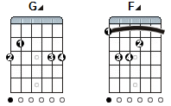
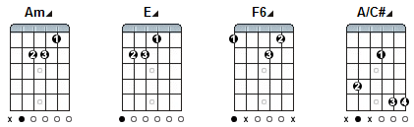
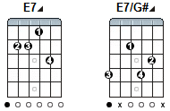
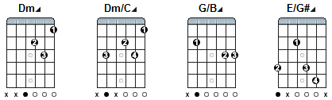
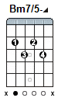

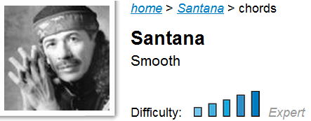

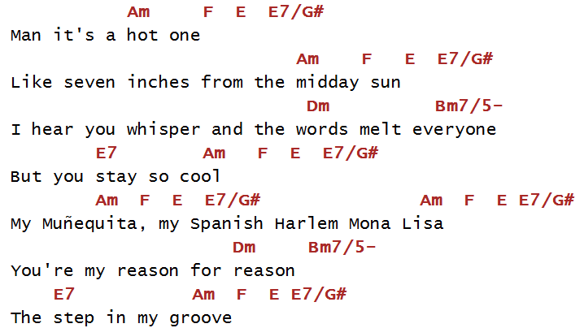
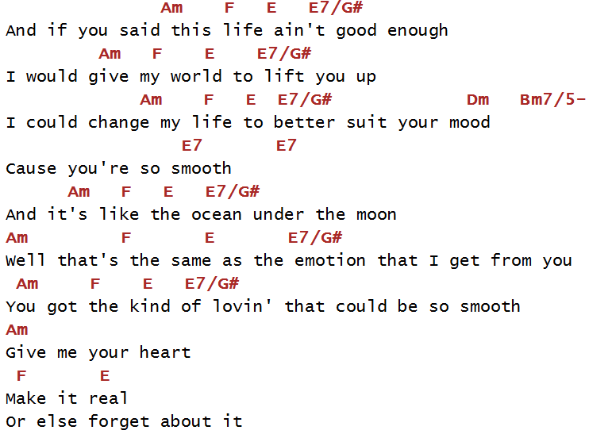

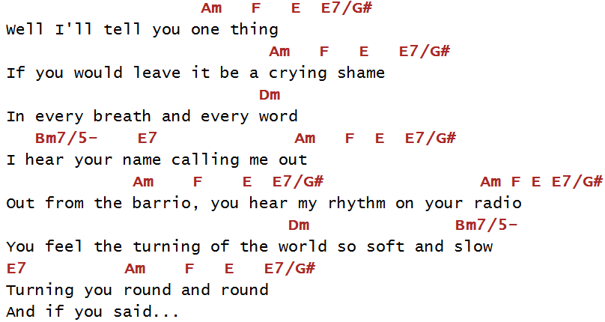

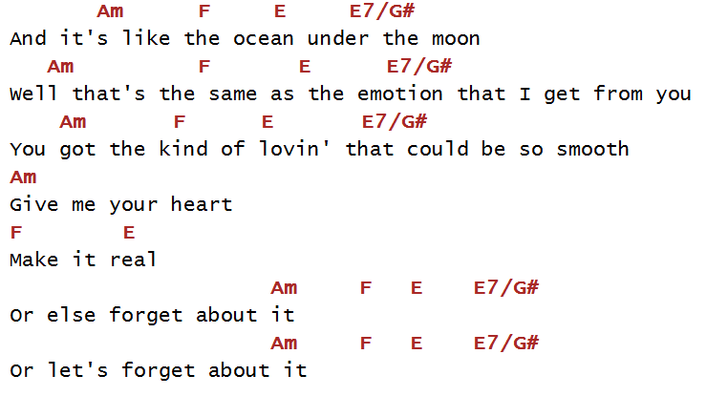

Smooth
=======================================================================
Artist : Santana
Album : Supernatural
Transcribed by : Najmul (najmul@homepage.com)
===============================================================================
e-mail me at najmul@homepage.com

********************************************************************************
Comments: Okay, I took six whole weeks just to transcribe this song to perfection
and I hope you would enjoy it. I gave the chords and the tabs for
the WHOLE song. The guitar should be in standard tuning and it is about
116 bpm.
********************************************************************************

KEY:
/ - slide
^ - bend full
b - bend half
h - hammer on
p - pull off

Chord Diagrams (low to high)
----- --------

Am X 0 2 2 1 0
F 1 3 3 2 1 1
E7 0 2 0 1 3 0
Dm7 X X 0 2 1 1
Dm7/C X 3 X 2 1 1
Bm7b5 X 2 3 2 3 X
E/G# 4 X 2 1 0 0
G7 3 5 3 4 3 3
F#7sus4 2 4 2 3 2 2

*Intro*

Am F E7
e|--------------|---------|--------------------------------------|
b|---------8----|---------|--9--10---12--12b-(12)---10--12-------|
g|----7h9-----9-|--10~~---|--------------------------------------|
d|--------------|---------|--------------------------------------|
a|--------------|---------|--------------------------------------|
e|--------------|---------|--------------------------------------|

Am F E7 Am F E7
e|--------------------------|-----------------------|-------------|
b|-13-10-10~~--------(10)\--|---------------------8-|-------------|
g|--------------------------|--7^---(7)b--(7)b------|-9\7--5------|
d|--------------------------|-----------------------|-------------|
a|--------------------------|-----------------------|-------------|
e|--------------------------|-----------------------|-------------|

Am F E7 Man, it's a
e|-----------------------------|--------------|------------|
b|-----------------------------|--------------|------------|
g|-(5)-4h5p4-------------------|--------------|------------|
d|-----------7--6--7--7/9---7--|--------------|------------|
a|-----------------------------|--------------|------------|
e|-----------------------------|--------------|------------|

Am F E7 Am F E7
hot one. Like seven inches from the midday sun
Dm7 Dm7/C E/G#
Well, I hear your whisper and the words melt everyone. But you stay so

Am F E7 Am F E7
cool My Munequita
e|-------------------7--8--7--|-10--8--7---------------------------|
b|----------------------------|-----------10--9--10--9--10~--(10)~-|
g|-----------5---7^-----------|------------------------------------|
d|----5--7--------------------|------------------------------------|
a|-7--------------------------|------------------------------------|
e|----------------------------|------------------------------------|

Am F E7
my Spanish Harlem Mona Lisa
e|-----------------------|-------10^---10^---8h10-------|
b|-----------------------|------------------------------|
g|-----------------------|------------------------------|
d|-----------------------|------------------------------|
a|-----------------------|------------------------------|
e|-----------------------|------------------------------|

Dm7 Dm7/C Bm7b5 E/G#
Well, you're my reason for reason, the step in
e|-(10)--10^~~------------------------------------------------|
b|------------------------------------------------------------|
g|------------------------------------------------------------|
d|------------------------------------------------------------|
a|------------------------------------------------------------|
e|------------------------------------------------------------|

Am F E7
my groove yeah And if you said
e|------------12----15p12-------12--12--|------------12~~--------(12)\----|
b|------15^-----------------15----------|-13----15------------------------|
g|--------------------------------------|---------------------------------|
d|--------------------------------------|---------------------------------|
a|--------------------------------------|---------------------------------|
e|--------------------------------------|---------------------------------|

*Chorus*

Am F E7 Am F E7
this life ain't good enough, I would give my world to
Am F E7
lift you up. I could change my life to better suit your mood

Dm7 Dm7/C Bm7b5 G7
because you're so smooth
e|----------------5--|-7-8h7p5~------------|-------12------12---15p12------12--------|
b|--3---3----5-6-----|---------------------|--15^-----15^--------------15-----15^----|
g|----7---7----------|---------------------|-----------------------------------------|
d|-------------------|---------------------|-----------------------------------------|
a|-------------------|---------------------|-----------------------------------------|
e|-------------------|---------------------|-----------------------------------------|

Am F E7
Well, and it's just like the ocean
e|-------------------------------------|--------------------------|
b|--15--13--15p13~---15p13~---15p13~---|--14----------------------|
g|-------------------------------------|--------------------------|
d|-------------------------------------|--------------------------|
a|-------------------------------------|--------------------------|
e|-------------------------------------|--------------------------|
Am F E7
under the moon. Well, its the same as the emotion that I get from you. You
Am F E7
got the kind of lovin' that can be so smooth, yeah

Dm7 E7 Am F E7
Gimme your heart make it real. Or else forget about it
e|-------------------------------|------------------------||----------------------|
b|--6\---------------------------|------------------------||-8h10~----------------|
g|--7\---------------------------|------------------------||----------------------|
d|--7\---------------------------|------------------------||----------------------|
a|--5\---------------------------|------------------------||----------------------|
e|----------------------------0--|------------------------||----------------------|

Well, I'll tell you
e|--------------------------------------|-------------------------10^---|-----------------(10)--|
b|-(10)--9--10--12--12b--(12)b---10--12-|-13--10---10~------------------|-----------------------|
g|--------------------------------------|-------------------------------|-----------------------|
d|--------------------------------------|-------------------------------|-----------------------|
a|--------------------------------------|-------------------------------|-----------------------|
e|--------------------------------------|-------------------------------|-----------------------|

*Verse*

Am F E7 Am F E7
one thing, if you would leave it's be a cryin' shame
e|-12\10---8------------|--------------------------|-------------------------|
b|------------10~-------|--------------------------|-------------------------|
g|----------------------|--------------------------|------------7^---7~------|
d|----------------------|--------------------------|-------------------------|
a|----------------------|--------------------------|-------------------------|
e|----------------------|--------------------------|-------------------------|

Dm7 Dm7/C Bm7b5 E/G#
In every breath and every word, I hear your name callin' me
e|-----------------------------------------------------------|
b|-----------------------------------------------------------|
g|-(7)-------------------------------------------------------|
d|-----------------------------------------------------------|
a|-----------------------------------------------------------|
e|-----------------------------------------------------------|

Am F E7 Am F E7
out. yeah Well out from the barrio
e|-------------5---7---8--7~--|--10--8--7--------------------||---------------|
b|--5--5---8------------------|------------10--9---10--9--10-||--(10)\--------|
g|----------------------------|------------------------------||---------------|
d|----------------------------|------------------------------||---------------|
a|----------------------------|------------------------------||---------------|
e|----------------------------|------------------------------||---------------|

Am F E7
you hear my rhythm on your radio And you feel the turning of the

Dm7 Dm7/C Bm7b5 E/G#
world so soft and slow, turnin' you
e|------------------------------5--|---8~----------------|
b|--------5----------------6-------|---------------------|
g|---7-----------------7-----------|---------------------|
d|------------7~-------------------|---------------------|
a|---------------------------------|---------------------|
e|---------------------------------|---------------------|

Am F E7
round. and round. And if you said
e|----------12---15p12-----12-----|----------12~--(12)\--------|
b|-----15^--------------15----15--|-13---15--------------------|
g|--------------------------------|----------------------------|
d|--------------------------------|----------------------------|
a|--------------------------------|----------------------------|
e|--------------------------------|----------------------------|

Am F E7 Am F E7
this life ain't good enough, I would give my world to
Am F E7
to lift you up. I could change my life to better suit your mood.

Dm7 Dm7/C Bm7b3 G7 F#7sus4 E7
because you're so smooth
e|--------------5---7--8--|----10--8--7--8--10----|------12-------12--15p12------12--------|
b|-------5--6-------------|-----------------------|--15^-----15^-------------15------15----|
g|---7--------------------|-----------------------|----------------------------------------|
d|------------------------|-----------------------|----------------------------------------|
a|------------------------|-----------------------|----------------------------------------|
e|------------------------|-----------------------|----------------------------------------|

Am F E7
Well, and it's just like the ocean
e|-------------------------------------|--------------------------|
b|--15--13--15p13~---15p13~---15p13~---|--14----------------------|
g|-------------------------------------|--------------------------|
d|-------------------------------------|--------------------------|
a|-------------------------------------|--------------------------|
e|-------------------------------------|--------------------------|

Am F E7
under the moon. Well, it's the same as the emotion that I get from you. You
e|---------------------------|--------------------|---------------------------|
b|--12~-------------12--13~--|----------------15--|--15~------------(15)\-----|
g|---------------14----------|--------------------|---------------------------|
d|---------------------------|--------------------|---------------------------|
a|---------------------------|--------------------|---------------------------|
e|---------------------------|--------------------|---------------------------|

Am F E7
got the kind of lovin' that can be so smooth, yeah
e|-------------12h13p12-----------12------|-------------------------------------|
b|-----------------------15---13------13--|-15---13---15---15---13~----(13)\----|
g|----------------------------------------|-------------------------------------|
d|----------------------------------------|-------------------------------------|
a|----------------------------------------|-------------------------------------|
e|----------------------------------------|-------------------------------------|

Dm7 E7
Gimme your heart make it real. Or else forget about it
e|-------------------------------|------------------------|
b|--6\---------------------------|------------------------|
g|--7\---------------------------|------------------------|
d|--7\---------------------------|------------------------|
a|--5\---------------------------|------------------------|
e|----------------------------0--|------------------------|

*Guitar Solo*

Am F E7 Am F E7
e|------------------------|-------------------------------|-----------------|
b|--8h10~--------------9--|----------9----12b--(12)--10~--|--------12--10---|
g|------------------------|-------------------------------|-----------------|
d|------------------------|-------------------------------|-----------------|
a|------------------------|-------------------------------|-----------------|
e|------------------------|-------------------------------|-----------------|

Am F E7
e|---------------------------------|------------------|--------------------------------------|
b|--9~--------9---12--13--12--10~--|---------12---9~--|------12---13--12h13p12--9--12h13p12--|
g|--------9------------------------|------------------|-------------------------9------------|
d|---------------------------------|------------------|--------------------------------------|
a|---------------------------------|------------------|--------------------------------------|
e|---------------------------------|------------------|--------------------------------------|

Am F E7 Am F E7
e|----------------------------------|--------------|----15^---15^---15^--(15)--12-------|
b|-(12)--10--10~--------------------|--------------|--------------------------------15--|
g|----------------------------------|--------------|------------------------------------|
d|----------------12h14---12h14--12-|----14~-------|------------------------------------|
a|----------------------------------|--------------|------------------------------------|
e|----------------------------------|--------------|------------------------------------|

Am F E7
e|--------12--12~--------19b---(19)---17--|--17~--------12h13p12---------12-------------12----|
b|--(15)----------------------------------|------------------------15---------13----15--------|
g|----------------------------------------|---------------------------------------------------|
d|----------------------------------------|---------------------------------------------------|
a|----------------------------------------|---------------------------------------------------|
e|----------------------------------------|---------------------------------------------------|

Am F E7
8va...................................................
e|---------------------17--19-20-19-|-20-19-20-19-20-19-20-19-20-19-20---|
b|--15~---(15)\----17---------------|------------------------------------|
g|----------------------------------|------------------------------------|
d|----------------------------------|------------------------------------|
a|----------------------------------|------------------------------------|
e|----------------------------------|------------------------------------|

Dm7 Dm7/C Dm7b5
8va.................................................................................................
e|--20--20^----(20)^---(20)p17-------17---|--17--17--17----17--17--17--17--17-------------------------|
b|------------------------------20^--20^--|----------20^-----------------------18--17--------17-------|
g|----------------------------------------|---------------------------------------------19^-------19--|
d|----------------------------------------|-----------------------------------------------------------|
a|----------------------------------------|-----------------------------------------------------------|
e|----------------------------------------|-----------------------------------------------------------|

G7 F#7sus4 E7
And it's
8va............................... loco
e|-----17-----------------------------------|----------------|--------------------------|
b|--17----20--17----------------------------|----------------|--------------------------|
g|---------------19^--(19)17----17-19\---9--|---10---11--12--|--13---14---15---16\14~---|
d|---------------------------19---------///-|--///--///-///--|-///--///--///------------|
a|------------------------------------------|----------------|--------------------------|
e|------------------------------------------|----------------|--------------------------|

*Chorus*

Am F E7 Am F E7
just like the ocean under the moon. Well, it's the same as the emotion that I
e|------------------|-------------------------------|-------------------------|
b|------------------|-----------------------12--13~-|---------------------15--|
g|-(14)~------------|--12~--------------14----------|-------------------------|
d|------------------|-------------------------------|-------------------------|
a|------------------|-------------------------------|-------------------------|
e|------------------|-------------------------------|-------------------------|

Am F E7
get from you. You got the kind of lovin' that can be so smooth, yeah
e|------------------|--------12h13p12----------12-----|-----------------------------|
b|-15~--------(15)\-|------------------15--13------13-|-15--13--15--15--13~--(13)\--|
g|------------------|---------------------------------|-----------------------------|
d|------------------|---------------------------------|-----------------------------|
a|------------------|---------------------------------|-----------------------------|
e|------------------|---------------------------------|-----------------------------|

Dm7 E7
Gimme your heart make it real. Or else forget about it
e|-------------------------------|------------------------|
b|--6\---------------------------|------------------------|
g|--7\---------------------------|------------------------|
d|--7\---------------------------|------------------------| N®
a|--5\---------------------------|------------------------|
e|----------------------------12-|--(12)\-----------------|

*Outro-Guitar Solo*

Am F E7 Am F E7
Or else forget about it Ah,
e|-----------------|--------------------------------|-------------------------10^---|
b|-8h10~-----------|-9--10--12--12b--(12)b---10--12-|-13--10---10~------------------|
g|-----------------|--------------------------------|-------------------------------|
d|-----------------|--------------------------------|-------------------------------|
a|-----------------|--------------------------------|-------------------------------|
e|-----------------|--------------------------------|-------------------------------|

Am F E7
let forget about it Ah, let's forget about it.
e|-(10)------------(10)-|--------------------|---------------------------------------|
b|----------------------|-8h10~--------------|----9--10-12--12^--(12)----10--12------|
g|----------------------|--------------------|---------------------------------------|
d|----------------------|--------------------|---------------------------------------|
a|----------------------|--------------------|---------------------------------------|
e|----------------------|--------------------|---------------------------------------|

Am F E7 Am F E7
Ah let's all forget about it yeah
(Gimme your heart make it real. Or else forget about it, Ah
e|------12--------------------------------|--------------------------|--13--13--13--13--13--13-----|
b|--13------13--13p12p10------10--10~-----|--------------------------|--12--12--12--12--12--12--12-|
g|------------------------12------------9-|-9~-9~-9~-9~-9~-9~-9~-9~--|-----------------------------|
d|----------------------------------------|--------------------------|-----------------------------|
a|----------------------------------------|--------------------------|-----------------------------|
e|----------------------------------------|--------------------------|-----------------------------|

Let's all forget about it Yeah, ah no. Oh, let's all forget about it
let's all forget about it)
e|----------------------|---12--12--12--12--12--12------|---12~-------------|
b|--(12)--15~-----------|---13--13--13--13--13--13--12--|-------------------|
g|----------------------|-------------------------------|-------------------|
d|----------------------|-------------------------------|-------------------|
a|----------------------|-------------------------------|-------------------|
e|----------------------|-------------------------------|-------------------|

Am F E7
Oh, no no Oh, let's all forget about it.
8va..............
e|--12--12--------12----15--12h15p12-----12--------------|-------------------17------17--|
b|----------15^-----------------------15-----15^--(15)^--|-------------------------------|
g|-------------------------------------------------------|---------------19^-----19^-----|
d|-------------------------------------------------------|-------------------------------|
a|-------------------------------------------------------|-------------------------------|
e|-------------------------------------------------------|-------------------------------|

Am F E7
Hey, ah oh, let's all forget about it
8va...............................................................................................
e|-------17----------17----17----17----17----17---|--19-19-19-19-19-19-19-19-19-19b--(19)---17--17-|
b|----------------------17----17----17----17------|------------------------------------------------|
g|19^----------19^--------------------------------|------------------------------------------------|
d|------------------------------------------------|------------------------------------------------|
a|------------------------------------------------|------------------------------------------------|
e|------------------------------------------------|------------------------------------------------|

Am F E7
8va.................................................................................................
e|--17--------17--17------17--17-------17--17--17----17--17--17-|-17--19---20--20^-(20)^---20---17~-|
b|------20^----------20^----------20^---------------------------|----///----------------------------|
g|--------------------------------------------------------------|-----------------------------------|
d|--------------------------------------------------------------|-----------------------------------|
a|--------------------------------------------------------------|-----------------------------------|
e|--------------------------------------------------------------|-----------------------------------|

Am F E7
8va............................................................................... loco
e|-17---------------------------------------------------|-----------------------------8p5--5~-|
b|-----20--17--17---------------------------------------|-------------------------------------|
g|-----------------19--19^--19--17------17--19^--19--17-|-19--17--19--17-19--17--19\----------|
d|----------------------------------19------------------|----------------------------7--------|
a|------------------------------------------------------|-------------------------------------|
e|------------------------------------------------------|-------------------------------------|

Am F E7
e|-5~------------|------5--7--7h8--7---10---5h7-|
b|--------5------|---5--------------------------|
g|------------7--|------------------------------|
d|---------------|------------------------------|
a|---------------|------------------------------|
e|---------------|------------------------------|

Am F E7
e|-(7)--5~------------------|------------------|
b|--------------6-------5~--|---------5--------|
g|--------------------------|----7h5-----------|
d|--------------------------|---------------7--|
a|--------------------------|------------------|
e|--------------------------|------------------|

*Begin Fade*

Am F E7 8va................................................
e|----------------------------7h8h10-12-12-|-----17-19-20-19-20p19p17-20p19p17-20p19p17--20p19p17--|
b|-------5--6-8-10---6-8-10----------------|-/17---------------------------------------------------|
g|--5--7-----------------------------------|-------------------------------------------------------|
d|-----------------------------------------|-------------------------------------------------------|
a|-----------------------------------------|-------------------------------------------------------|
e|-----------------------------------------|-------------------------------------------------------|

Am F E7
8va....................................................................................................
e|-20p19p17-20p19p17-20p19p17-20p19p17-20p19p17-20p19p17-20p19p17-21-|-22p20p19-22p20p19-22p20p19-22^-22-|
b|-------------------------------------------------------------------|-------------------------------///-|
g|-------------------------------------------------------------------|-----------------------------------|
d|-------------------------------------------------------------------|-----------------------------------|
a|-------------------------------------------------------------------|-----------------------------------|
e|-------------------------------------------------------------------|-----------------------------------|

Am F E7 Am F E7
8va................................................................................
e|-(22)------(22)-|--22--20--22------|----------------------------------------------|
b|-///-------///--|-------------22~--|---20-22-22--20-22-22--20-22-20-19------------|
g|----------------|------------------|------------------------------------22p21p19--|
d|----------------|------------------|----------------------------------------------|
a|----------------|------------------|----------------------------------------------|
e|----------------|------------------|----------------------------------------------|

Am F E7 *Fade Out*
8va................................................................................
e|------------------------20h22--20-|-17~--------------|-----17--19-19h20--19--20--|
b|----------------------------------|----------17------|-17------------------------|
g|--21p19/p17-----------------------|--------------19--|---------------------------|
d|------------19~--(19)\------------|------------------|---------------------------|
a|----------------------------------|------------------|---------------------------|
e|----------------------------------|------------------|---------------------------|

Smooth - Bass Tab
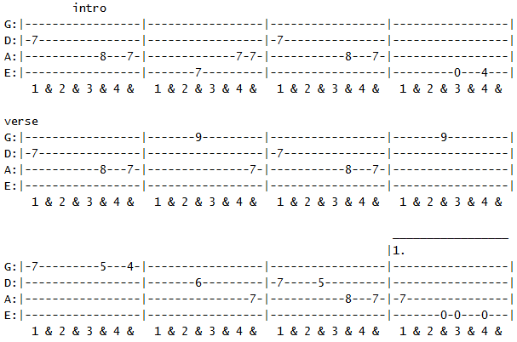

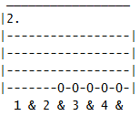

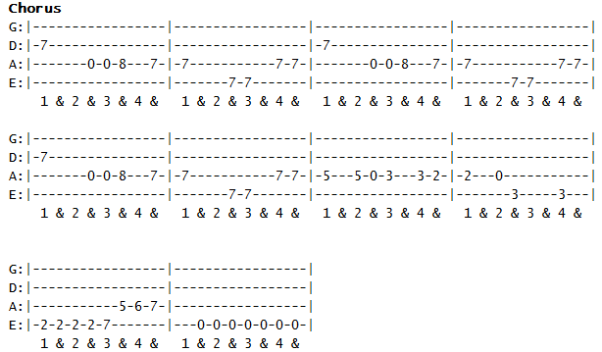

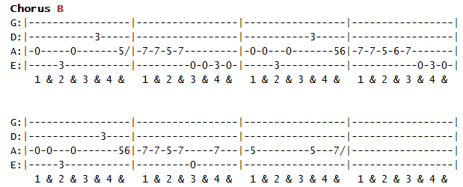

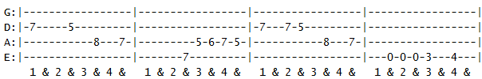
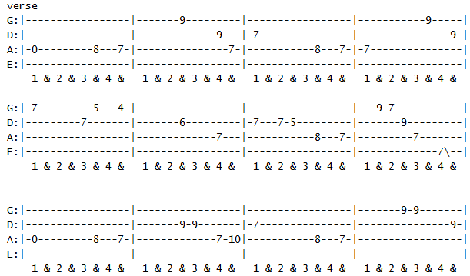

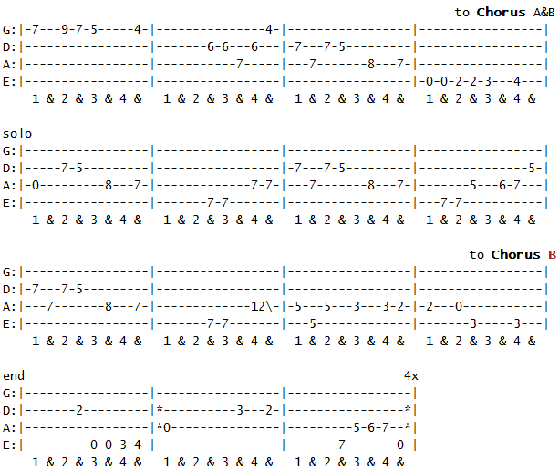

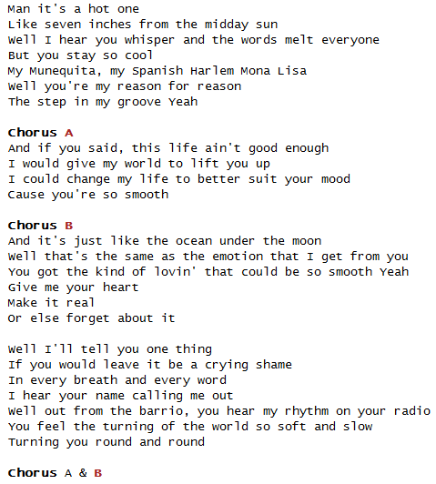
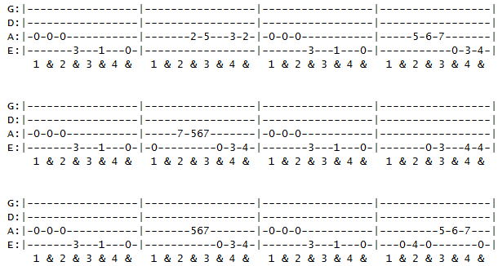
Smooth - Drums Tab
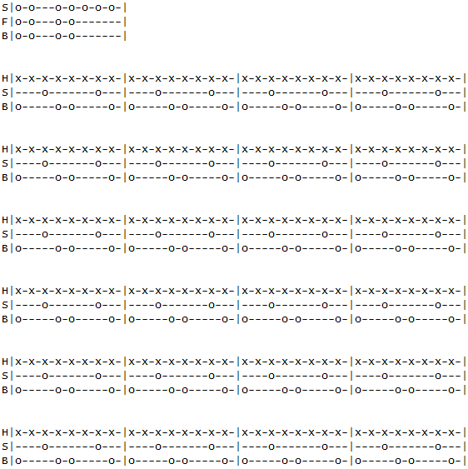

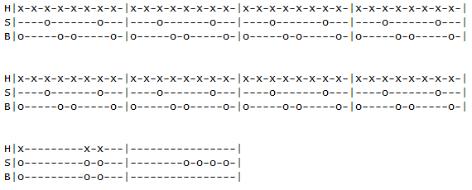

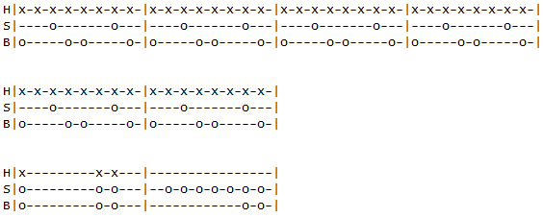

El-Farol
Artist: Santana
Title: El Farol
Album: Supernatural
Transcribed by: jordanlockert@yahoo.com

I worked out the fast part now, and it wasn't as difficult as I thought
it would be. Its not that its super fast or anything, its just because
there's so many notes in a row, it gets sort of mind numbing. For clarity,
I've really spaced it apart more than usual. My advice for learning it would
be to study and memorize it, and then try to play along with the song.
For the most part, all of it follows the C major scale played at the 12 position
and dont forget to use one finger per fret

Intro: Classical guitar
|------------------------|
|------------------------|
|------13h14p13----------|
|-14h15--------15p14-----|
|------------------------|
|------------------------|

|------------------------------------------------------------|
|------------------------------------------------------------|
|------13h14-13h14-13h14p13----------------------------------|
|-14h15---------------------14h15-14h15p14--12h14p12---------|
|----------------------------------------------------15------|
|------------------------------------------------------------|

Electric
|------------------------------------------------------------|
|-13-----------------------13-12-----------------------------|
|------------------------------------------------------------|
|------------14-15-----------------------12-14---------------|
|------------------------------------------------------------|
|------------------------------------------------------------|

|--------------------------------------------------------------------------|
|--------------------------------------------------------------------------|
|-14------------------------------14-13------------------------------------|
|---------------12----------12-15--------15-14--12-----12-14-12-14---------|
|------------15----------14-------------------------15---------------------|
|--------------------------------------------------------------------------|

|----------------------------------------------------------------------|
|-13-----------------------13-12---------------------------------------|
|--------------------------------------------12------------------------|
|------------14-15------15----------------12----12-14-14-14------------|
|----------------------------------------------------------------------|
|----------------------------------------------------------------------|

|--------------------------------------------------------------------------|
|--------------------------------------------------------------------------|
|-14------------------------------14-13h14p13------------------------------|
|---------------12----------12-15--------------15-14--12-----12-14-12-14---|
|------------15----------14-------------------------------15---------------|
|--------------------------------------------------------------------------|

|------------------------------------------------------------------------|
|------------------------------------------------------------------------|
|-------------------------12---------------------------------------------|
|----14----14-12--12--15--------14--------------12-14-12--12------12-----|
|-15----15--------------------------------12-15---------------14-----15--|
|------------------------------------------------------------------------|

|---------------------------------------------------------------------------|
|---------------------------------------------------------------------------|
|-------------------------12------------------------------------------------|
|----14----14-12--14--15------14p12h14-----------12-14-12-------------------|
|-15----15---------------------------------12-15-----------14--11-----14-12-|
|------------------------------------------------------------------12-------|

|--------------------------------------------------------------------|
|--------------------------------------------------------------------|
|--------------------------------------------12----------------------|
|---------------------------12-----12-14--------15-14----------------|
|-11-12-14--12-14-15--14-15-----15-----------------------------------|
|--------------------------------------------------------------------|

|------------------------------------------------------------|
|-13-----------------------13-12-----------------------------|
|------------------------------------------------------------|
|------------14-15-----------------------12-14-14------------|
|------------------------------------------------------------|
|------------------------------------------------------------|

|--------------------------------------------------------------------------|
|--------------------------------------------------------------------------|
|-14------------------------------14-13------------------------------------|
|---------------12----------12-15--------15-14--12-----12-14-12-14---------|
|------------15----------14-------------------------15---------------------|
|--------------------------------------------------------------------------|

|----------------------------------------------------------------------|
|-13-----------------------13-12---------------------------------------|
|--------------------------------------------12------------------------|
|------------14-15------------------------12----12-14-14-14------------|
|----------------------------------------------------------------------|
|----------------------------------------------------------------------|

|-----------------------------------------------------------------------|
|-----------------------------------------------------------------------|
|-14------------------------------14-13---------------------------------|
|---------------12----------12-15--------15-12h14--12-----12-14-12-14---|
|------------15----------14----------------------------15---------------|
|-----------------------------------------------------------------------|

|------------------------------------------------------------------------|
|------------------------------------------------------------------------|
|-------------------------12---------------------------------------------|
|----14----14-12--12--15--------14--------------12-14-12-----------------|
|-15----15--------------------------------12-15-----------14------14-12--|
|-------------------------------------------------------------15---------|

|---------------------------------------------------------------------------|
|---------------------------------------------------------------------------|
|-------------------------12------------------------------------------------|
|----14----14-12--14--15------14p12h14-----------12-14-12-------------------|
|-15----15---------------------------------12-15-----------14--11-----14-12-|
|------------------------------------------------------------------12-------|

|---------------------------------------------------------------
|---------------------------------------------------------------
|----------------------------12----------14---------------------
|-------12-14-12-------12-14----15-14-15----15-14h15p14p12h14---
|-12-15-------------15------------------------------------------
|---------------------------------------------------------------

-------------------------------|
-------------------------------|
-------------------------------|
-------12-14-12----------------|
-12-15-----------14--11-----14-|
-------------------------12----|

|-------------------------------------------------------------------|
|----------------------------------------------------------------12-|
|--------------------------------------------12--------------14-----|
|---------------------------12-----12-14--------15-14-----14--------|
|-11-12-14--12-14-15--14-15-----15----------------------------------|
|-------------------------------------------------------------------|

|------------------------------------------------------------|
|-13-----------------------13-12-----------------------------|
|------------------------------------------------------------|
|------------14-15-----------------------12-14-14------------|
|------------------------------------------------------------|
|------------------------------------------------------------|

|---------------------------------------------------------------------------|
|---------------------------------------------------------------------------|
|-14------------------------------14-13h14p13-------------------------------|
|---------------12----------12-15--------------15-12h14--12-----12-14-12-14-|
|------------15----------14----------------------------------15-------------|
|---------------------------------------------------------------------------|

faster part
|-------------12--13--12--13--15--13--12--13--12--13--12--13------12------12-
|-12--13--15--------------------------------------------------15------15-----
|----------------------------------------------------------------------------
|----------------------------------------------------------------------------
|----------------------------------------------------------------------------
|----------------------------------------------------------------------------

---------------------------------------------------------------------------
-13--15--13p12--13--12--13--15--13--12--13--13p12--------------------------
---------------------------------------------------14--12------------------
-----------------------------------------------------------12--------------
---------------------------------------------------------------15--12--15--
---------------------------------------------------------------------------

-------------------------------------------|
-------------------------------------------|
--------12--12--12h14--14--12h14p12--------|
-12h14-------------------------------------|
-------------------------------------------|
-------------------------------------------|

|-15^--15---15------13---12-----13---12-------13--12----------12-------------
|-----------------------------------------15----------15--13------15--13--12-
|----------------------------------------------------------------------------
|----------------------------------------------------------------------------
|----------------------------------------------------------------------------
|----------------------------------------------------------------------------

--------------------------------------------------------12----------|
-15--13--12--15--13--12--13p12--------------12--13--15--------------|
--------------------------------14--13--14--------------------------|
--------------------------------------------------------------------|
--------------------------------------------------------------------|
--------------------------------------------------------------------|

|-12--17--12--17--12--17--12--19--12--19--12--19--12--20------
|-------------------------------------------------------------
|-------------------------------------------------------------
|-if you cant stretch your fingers far enough-----------------
|-play the 12th fret E note on the B string-------------------
|-------------------------------------------------------------

-20^---20^--20^--20^--20^-r--17------17h20p17------17-----------------------
---------------------------------20------------20------20--17---------------
---------------------------------------------------------------19^---19--17-
----------------------------------------------------------------------------
----------------------------------------------------------------------------
----------------------------------------------------------------------------

-----------------17----------------------------------------------------
-------------17------20--17--------------------------------------------
-----17--19^-----------------19^-19--17------17--19--19--17---17-17----
-19--------------------------------------19----------------------------
-----------------------------------------------------------------------
-----------------------------------------------------------------------

----------------------------------------|
----------------------------------------|
----------------------------------------|
-19--17-------------------------17------|
---------17--------------17h19----------|
-------------20--17--20-----------------|

|-15^--15--15-----13--12------13---12--12----------------12--13--12----------
|--------------------------------------------15--13--15--------------15--13--
|----------------------------------------------------------------------------
|----------------------------------------------------------------------------
|----------------------------------------------------------------------------
|----------------------------------------------------------------------------

-12-------------------------------------------------------------------------
-----15--13--12--15--13--12--13--12--13--12--13--12--13---13---12--13--15---
----------------------------------------------------------------------------
----------------------------------------------------------------------------
----------------------------------------------------------------------------
----------------------------------------------------------------------------

---------12--------12--13----12--13--12--
-13--15--------15------------------------
-----------------------------------------
-----------------------------------------
-----------------------------------------
-----------------------------------------

|-------------------------------------------------------------------|
|-13--13--13----------------------13-12-----------------------------|
|-------------------------------------------------------------------|
|-----------------14-15-----------------------12-14-----------------|
|-------------------------------------------------------------------|
|-------------------------------------------------------------------|

|-----------------------------------------------------------------------
|-----------------------------------------------------------------------
|-14------------------------------14-13---------------------------------
|---------------12----------12-15--------15-14--12-----12-14-----12-14--
|------------15----------14-------------------------15--------15--------
|-----------------------------------------------------------------------

-----------------------------|
-----------------------------|
-----------------------------|
----12-14-----12-14----12----|
-15--------15-------15-------|
-----------------------------|

|-----------------------------------------------------------------------
|-----------------------------------------------------------------------
|-------------------12--------------------------------------------------
|-14--------12--14------15--14--12------12--14-------12--14--14--15--15-
|-------15--------------------------15-----------15---------------------
|-----------------------------------------------------------------------

---------------------------------12--15--13--12--13--12--13------12---------
-----------------12--12--13--15------------------------------15------15--13-
-12--12--14--14-------------------------------------------------------------
----------------------------------------------------------------------------
----------------------------------------------------------------------------
----------------------------------------------------------------------------

-------------12------|
-12--13--15----------|
---------------------|
---------------------|
---------------------|
---------------------|

|-12--17--17---17---19---20--19h20-------20^--20^---20^---20^----20^----20^--
|----------------------------------------------------------------------------
|----------------------------------------------------------------------------
|----------------------------------------------------------------------------
|----------------------------------------------------------------------------
|----------------------------------------------------------------------------

-20^----20^--20^-r---20--17---------------------------------------------
-----------------------------20--17-----------------------------17--17--
-------------------------------------19^---19--17------17--19^----------
---------------------------------------------------19-------------------
------------------------------------------------------------------------
------------------------------------------------------------------------

--------------------------------------------------------|
----17-17-17----17-17-17----17-17-17----17-17-17b*------|
-19^---------19^---------19^---------19^----------------|
--------------------------------------------------------|
--------------------------------------------------------|
--------------------------------------------------------|
* bend three semitones (to 20)

|-------------------------15--13--12--13--13p12------12--------------12------
|-15--13--15--13--15--13-------------------------15------15--13--15------15--
|----------------------------------------------------------------------------
|----------------------------------------------------------------------------
|----------------------------------------------------------------------------
|----------------------------------------------------------------------------

--------------------|
-13--12h13p12-------|
--------------------|
--------------------|
--------------------|
--------------------|

|------------------------------------------------------------------------|
|--15--13--12--13--12----------------------------------------------------|
|----------------------14--12------------------------12--12--12-12--12---|
|------------------------------12--------------12h14---------------------|
|----------------------------------15--12--15----------------------------|
|------------------------------------------------------------------------|

|-15h17--15--15-----------------13--12--12---------------------12----------
|-----------------18--17---------------------15--15----13--15------15--13--
|--------------------------------------------------------------------------
|--------------------------------------------------------------------------
|--------------------------------------------------------------------------
|--------------------------------------------------------------------------

-----12--15--13--12--------------12-------------------------------------------
-15------------------15--13--15------15--13--12--13--12--13----12---12--------
-------------------------------------------------------------------------14---
------------------------------------------------------------------------------
------------------------------------------------------------------------------
------------------------------------------------------------------------------

------------------------------------------------------15-------12--12--12--12-
---------------12--13----------13h15-------15-----15------15------------------
--14-------14-----------------------------------------------------------------
-------14---------------------------------------------------------------------
------------------------------------------------------------------------------
------------------------------------------------------------------------------

|-17--12------12--------------------------------
|---------15------15----20--15------15----------
|-------------------------------17------17------
|-----------------------------------------------
|-----------------------------------------------
|-----------------------------------------------faded out

